K.S.R.M. COLLEGE OF ENGINEERING

(UGC - AUTONOMOUS)
Approved by AICTE, New Delhi & Affiliated to JNTUA, Ananthapuramu
(Accredited by NAAC with A+ Grade & B.Tech.(Civil, EEE, Mech, ECE and CSE) Programs by NBA)

KADAPA – 516 005 (A.P.)

DEPARTMENT OF COMPUTER SCIENCE AND ENGINEERING

CERTIFICATE
This is to certified that the project report entitled “STOCK PRICE FORECASTING USING LSTM AND GRU” is being submitted by BYREDDY GOWTHAMI (219Y1A0517), KAMISETTY LAKSHMI PRASANNA (219Y1A0573), GAMPALA GRESU DEEVANA (219Y1A0548), CHINTHAKUNTA
INDRA KUMAR (219Y1A0527) to K.S.R.M. College of Engineering (UGC - AUTONOMOUS), Kadapa in partial fulfilment of the requirements for the award of the degree of “BACHELOR OF TECHNOLOGY” in “COMPUTER SCIENCE AND ENGINEERING” is a bonafide record of the project work carried out by them under our supervision during the period 2024-2025.

Project Guide  Miss. T.Anitha, M.Tech.  Assistant Professor Department of CSE | Head of the Department  Dr. V. Venkata Ramana M.Tech., Ph.D Professor & HoD  Department of CSE

Date: Internal Examiner External Examiner

DECLARATION BY THE CANDIDATES

We BYREDDY GOWTHAMI (219Y1A0517), KAMISETTY LAKSHMI PRASANNA (219Y1A0573), GAMPALA GRESU DEEVANA (219Y1A0548), CHINTHAKUNTA INDRA
KUMAR (219Y1A0527) hereby declare that the Project Report entitled “STOCK PRICE FORECASTING USING LSTM AND GRU” under the guidance Miss.T.ANITHA, M.Tech., Assistant Professor , Department of CSE is submitted in partial fulfillment of the requirements for the award of the degree of Bachelor of Technology in Computer Science and Engineering.
This is a Record of bonafide work carried out by me and the results embodied in this Project Report have not been reproduced or copied from any source. The results embodied in this Project Report have not submitted to any other University or Institute for the Award of any other Degree or Diploma.

By
BYREDDY GOWTHAMI (219Y1A0517) KAMISETTY LAKSHMI PRASANNA (219Y1A0573) GAMPALA GRESU DEEVANA (219Y1A0548) CHINTHAKUNTA INDRA KUMAR (219Y1A0527)
Dept. of Computer Science & Engineering
K.S.R.M. College of Engineering (A) Kadapa-516 005.AP

ACKNOWLEDGEMENT

An endeavour over a long period can be successful only with the advice and supports of many well-wishers. We take this opportunity to express our gratitude and appreciation to all of them.
We are extremely thankful to our beloved Managing Director
Dr. K CHANDRA OBUL REDDY GARU who took keen interest and encouraged us in every effort throughout this course.
We wish to express our deepest sense of gratitude and pay our sincere thanks to our guide Miss.T.ANITHA, M.Tech., Department of Computer Science and Engineering, K.S.R.M. College of Engineering (A), Kadapa for his valuable guidance and suggestions in analysing and testing throughout the period, till the end of project work completion and his timely suggestions and help. We are very much thankful to Dr. V VENKATA RAMANA M.Tech., Ph.D, Professor,
Head of the Department for Computer Science and Engineering, K.S.R.M. College of Engineering (A), Kadapa for providing good facilities & congenial atmosphere in our college.
We take this opportunity to express our deep gratitude and appreciation to all those who encouraged us for successfully completion of this Project work. We wish to express our sincere to gratitude to Dr. T NAGESWARA PRASAD, M.Tech., Ph.D. Vice Principal of K.S.R.M. College of Engineering(A), Kadapa and Dr. V.S.S. MURTHY, M.Tech., Ph.D. Principal of K.S.R.M. College of Engineering(A), Kadapa and for their consistent help and encouragement to complete the project work.
We also thankful to all teaching and non-teaching staff of the Department of Computer Science and Engineering for their support throughout our B.Tech. course.
We express our heartfelt thanks to My Parents for their valuable support and encouragement in completion of my course. Also I express my heartfelt regards to my Friends for being supportive in completion of my project.

Project Associates

BYREDDY GOWTHAMI (219Y1A0517) KAMISETTY LAKSHMI PRASANNA (219Y1A0573) GAMPALA GRESU DEEVANA (219Y1A0548) CHINTHAKUNTA INDRA KUMAR (219Y1A0527)

VISION & MISSION

VISION:
To evolve as center of repute for providing quality academic programs amalgamated with creative learning and research excellence to produce graduates with leadership qualities, ethical and human values to serve the nation.
MISSION:

M1: To provide high quality education with enriched curriculum blended with impactful teaching- learning practices.
M2: To promote research, entrepreneurship and innovation through industry collaborations.

M3: To produce highly competent professional leaders for contributing to Socio-economic development of region and the nation.

DEPARTMENT OF COMPUTER SCIENCE AND ENGINEERING
VISION & MISSION

VISION:
To evolve as a recognized center of excellence in the area of Computer Science and Engineering and other related inter-disciplinary fields.
MISSION:

M1: To produce competent and industry ready professionals through well balanced curriculum and innovative pedagogy.
M2: To provide conducive environment for research by establishing centre of excellence and industry collaborations.
M3: To instill leadership qualities, ethical values among students through various co-curricular and extracurricular activities.

PROGRAMME OUTCOMES

PO1 - Engineering Knowledge: Apply the knowledge of mathematics, science, engineering fundamentals, and an engineering specialization to the solution of complex engineering problems.
PO2 - Problem Analysis: Identify, formulate, review research literature, and analyze complex engineering problems reaching substantiated conclusions using first principles of mathematics, natural sciences, and engineering sciences.
PO3 - Design/Development of solutions: Design solutions for complex engineering problems and design system components or processes that meet the specified needs with appropriate consideration for the public health and safety, and the cultural, societal, and environmental considerations.
PO4 - Conduct investigations of complex problems: Use research-based knowledge and research methods including design of experiments, analysis and interpretation of data, and synthesis of the information to provide valid conclusions.
PO5 - Modern tool usage: Create, select, and apply appropriate techniques, resources, and modern engineering and IT tools including prediction and modelling to complex engineering activities with an understanding of the limitations.
PO6 - The engineer and society: Apply reasoning informed by the contextual knowledge to assess societal, health, safety, legal and cultural issues and the consequent responsibilities relevant to the professional engineering practice.
PO7 - Environment and sustainability: Understand the impact of the professional engineering solutions in societal and environmental contexts, and demonstrate the knowledge of, and need for sustainable development.
PO8 - Ethics: Apply ethical principles and commit to professional ethics and responsibilities and norms of engineering practice.
PO9 - Individual and team work: Function effectively as an individual, and as a member or leader in diverse teams, and in multidisciplinary settings.
PO10 - Communication: Communicate effectively on complex engineering activities with the engineering community and with society at large, such as, being able to comprehend and write effective reports and design documentation, make effective presentations, and give and receive clear instructions.
PO11 - Project management and finance: Demonstrate knowledge and understanding of the engineering and management principles and apply these to one's own work, as a member and leader in a team, to manage projects and in multidisciplinary environments.
PO12 - Life-long learning: Recognize the need for, and have the preparation and ability to engage in independent and life-long learning in the broadest context of technological change.

PROGRAMME SPECIFIC OUTCOMES

PSOs are statements that describe what the graduates of a specific engineering program should be able to do:
PSO1 - Professional Skills: The ability to understand, analyze and develop computer programs in the areas related to algorithms, system software, multimedia, web design, big data analytics, and networking for efficient design of computer-based systems of varying complexity.
PSO2 - Problem-Solving Skills: The ability to apply standard practices and strategies in software project development using open-ended programming environments to deliver a quality product for business success.
PSO3 - Successful Career and Entrepreneurship: The ability to employ modern computer languages, environments, and platforms in creating innovative career paths to be an entrepreneur, and a zest for higher studies.

Table of Contents

 |  |  | Description | Page No.
 |  |  | Abstract | ix
 |  |  | List of Abbreviations | xi
 |  |  | List of Figures | xii
 |  |  | List of Tables | xiii
CHAPTER-1 |  |  | INTRODUCTION | 1 – 10
 | 1.1 |  | Introduction | 1
 | 1.2 |  | Domain Description about the area of project | 2
 | 1.3 |  | Problem Definition | 3
 | 1.4 |  | Proposed Solution | 6
 | 1.5 |  | Objectives | 7
 | 1.6 |  | Organization of the Project report | 10
CHAPTER-2 |  |  | LITERATURE SURVEY | 11-22
 | 2.1 |  | Introduction | 11
 | 2.2 |  | Related Work
 | 2.3 |  | Overview | 22
CHAPTER-3 |  |  | SYSTEM ANALYSIS | 23-40
 | 3.1 |  | Introduction | 23
 | 3.2 |  | Existing System & Disadvantages
 | 3.3 |  | Proposed System &Advantages
 | 3.4 |  | Software Requirements
 | 3.5 |  | Hardware Requirements
 | 3.6 |  | Modules Description
 |  | 3.6.1 | Module 1
 |  | 3.6.1 | Module 2
 | 3.7 |  | System Architecture
 | 3.8 |  | Feasibility Study
 |  | 3.8.1 | Economic Feasibility
 |  | 3.8.2 | Technical Feasibility
 |  | 3.8.3 | Procedural Feasibility
 | 3.9 |  | System Requirements
 |  | 3.9.1 | Hardware Requirements
 |  | 3.9.2 | Software Requirements | 40
CHAPTER-4 |  |  | SYSTEM DESIGN | 41-45
 | 4.1 |  | Introduction | 41
 | 4.2 |  | DFD Diagrams
 | 4.3 |  | UML Diagrams
 |  | 4.3.1 | Use Case Diagram
 |  | 4.3.2 | Sequence Diagram
 |  | 4.3.3 | Class Diagram
 |  | 4.3.4 | Collaboration Diagram
 |  | 4.3.5 | Activity Diagram | 45
CHAPTER-5 |  |  | SYSTEM CODING AND TESTING | 46-49
 | 5.1 |  | Introduction | 46
 | 5.2 |  | Implementation
 | 5.3 |  | About Python

 | 5.4 |  | Sample Code
 | 5.5 |  | Software Testing Techniques
 | 5.6 |  | Software Testing Strategies | 49
CHAPTER-6 |  |  | RESULTS | 50-54
 | 6.1 |  | Introduction | 50
 | 6.2 |  | Output Screens | 54
CHAPTER-7 |  |  | CONCLUSION AND FUTURE ENHANCEMENT | 55-56
 | 7.1 |  | Conclusion | 55
 | 7.2 |  | Future Enhancements | 56
 |  |  | REFERENCES | 57-60
 |  |  | Appendix-1 (Publication Details) | 61
 |  |  | Appendix-2 | 62
 |  |  | CO-PO & PSO mapping | 63
 |  |  | Rubrics for Evaluation | 64
 |  |  | Bio-Data of Team Members | 66

ABSTRACT

The Stock Market Analyzer is an AI-powered web application designed to make stock market analysis accessible and easy to understand for users of all backgrounds. It integrates technical indicators, sentiment analysis, and deep learning models to offer real-time insights and future stock price predictions.
By leveraging historical data from Yahoo Finance, the system performs calculations for indicators such as SMA, EMA, RSI, and MACD to provide technical insights. Simultaneously, it analyzes news headlines using natural language processing to determine the market sentiment around a stock.
For forecasting, the app uses advanced neural networks like LSTM and GRU to predict stock prices based on past trends. The application also evaluates risk and identifies bullish or bearish market trends.
Built using Python, Streamlet, TensorFlow, and Plotly, this tool is ideal for investors, traders, and beginners who wish to explore the power of AI in financial decision-making.
This project aims to simplify complex financial data into actionable insights, enabling more informed investment.

LIST OF ABBREVIATIONS

ABBREVIATION | FULL FORM
AI | Artificial Intelligence
LSTM | Long Short-Term Memory
GRU | Gated Recurrent Unit
SMA | Simple Moving Average
EMA | Exponential Moving Average
RSI | Relative Strength Index
MACD | Moving Average Convergence Divergence
NLP | Natural Language Processing

LIST OF FIGURES

Figure No | Diagram | Page No
1 | System Architecture | 32
2 | Data Flow Diagram | 39
3 | Use case Diagram | 41
4 | Sequence Diagram | 42
5 | Class Diagram | 43
6 | Collaboration Diagram | 44
7 | Activity Diagram | 45
8 | Home page | 73
9 | Today’s Top Performers | 73
10 | Real Time User Predictions | 74
11 | Real Time User Predictions | 74

LIST OF TABLES

S.No | Table No | Table Name | Page No
1 | 1 | Test Cases | 54

CHAPTER 1

Introduction 1-10
  - Introduction
  - Domain Description about the Area of Project
  - Problem Definition
  - Proposed Solution
  - Objective
  - Organization of the Project report

1.1 Introduction

INTRODUCTION

The Stock Market is influenced by various factors, including historical trends, technical indicators, and real-time news. Understanding these elements can be overwhelming for many investors—especially beginners.
The Stock Market Analyzer was developed to simplify this complexity using a combination of data science and artificial intelligence.

This web-based application allows users to select any stock, view its historical performance, analyze technical indicators, and receive AI-powered future price predictions.
It incorporates sentiment analysis by scanning recent news headlines and evaluating their impact on the stock's performance.
The application uses LSTM and GRU neural networks for accurate forecasting and indicators like SMA, EMA, RSI, and MACD for trend analysis.
With an intuitive interface built using Streamlit and visualized through Plotly, this tool empowers users to make informed decisions based on data-driven insights.
It is ideal for traders, investors, and anyone curious about the stock market and AI-based analysis.

1.2Domain Description about the area of project

The Stock Market domain is a dynamic and complex environment where securities such as stocks, bonds, and derivatives are bought and sold. It plays a crucial role in the economy by enabling companies to raise capital and providing investors with opportunities for wealth generation. However, due to its volatile and unpredictable nature, analyzing stock trends and making informed decisions is often challenging—especially for new or non-technical users.
In recent years, the integration of Artificial Intelligence (AI) and Data Science in stock market analysis has revolutionized how investors and analysts interact with financial data. AI-driven systems can identify patterns, predict trends, and analyze large datasets much faster and more accurately than traditional manual methods. Techniques such as time-series forecasting, technical analysis, and sentiment analysis are widely used to evaluate market conditions and anticipate stock movements.

This project falls under the domain of Financial Data Analysis using AI. It incorporates key sub-domains such as Machine Learning, Natural Language Processing (NLP), and Time Series Analysis. By leveraging neural networks like LSTM (Long Short-Term Memory) and GRU (Gated Recurrent Unit), the system can learn from historical data and generate future stock price predictions. These deep learning models are particularly effective for sequential data, making them well-suited for the fluctuating nature of stock prices.

The domain also includes technical analysis, which involves evaluating stocks based on past price movements and technical indicators like SMA (Simple Moving Average), EMA (Exponential Moving Average), RSI (Relative Strength Index), and MACD (Moving Average Convergence Divergence). These indicators help in identifying trends, momentum, and possible reversals.

Another significant aspect of the domain is sentiment analysis, where the application uses NLP techniques to interpret the tone of financial news headlines. Positive or negative sentiment can influence investor behavior and impact stock performance.

In summary, this project lies at the intersection of finance, machine learning, and user-centric design. The goal is to democratize access to stock analysis tools, enabling users—whether experienced traders or curious beginners—to gain actionable insights through an AI-powered, user-friendly platform. This represents a modern approach to financial decision-making, driven by data and guided by intelligent systems.

Problem Definition
The stock market is one of the most dynamic and unpredictable financial systems in the world. Investors and traders constantly seek ways to maximize profits while minimizing risks. However, making informed decisions in the stock market requires deep knowledge of financial indicators, awareness of current market sentiment, and the ability to analyze large volumes of data quickly. These requirements create significant barriers for beginners and even pose challenges to experienced investors.
The vast and often unstructured nature of financial data—ranging from historical stock prices to news articles—adds to the complexity. Furthermore, the lack of accessible tools that combine technical analysis, sentiment analysis, and AI-driven forecasting limits the ability of the average user to participate confidently in the market. This project aims to address these limitations through a unified, easy-to-use platform that simplifies complex stock analysis.

Most stock analysis platforms available today are either too complicated for beginners or too limited in their scope for serious traders. They typically focus on just one area—like displaying charts or providing technical indicators—without offering holistic insights that combine historical data, predictive modeling, and current sentiment. Moreover, many platforms lack automation or AI-based forecasting tools that help users project future price trends in an intelligent, data-driven manner.
In addition, global users face a challenge in understanding international stocks due to currency differences. For example, an Indian investor looking at a U.S.-based stock like Apple (AAPL) must manually convert prices into INR for better context, which can be tedious and error-prone.

Another major issue is the underutilization of natural language processing (NLP) in conventional platforms. While news headlines have a strong influence on stock prices, very few platforms leverage sentiment analysis to interpret how news might affect a particular stock. This leaves a gap in understanding how qualitative data (like news) correlates with quantitative metrics (like stock prices).

User-Specific Challenges

- Beginners often struggle with understanding charts, indicators, and financial jargon.

- Retail investors find it hard to keep up with real-time news and assess its impact.

- Traders lack AI-assisted tools that can provide quick future predictions to support time-sensitive decisions.
- Students and learners do not have hands-on tools that connect textbook concepts with real-world applications.
These diverse user groups need a platform that simplifies financial analysis and reduces the need for manual data processing or advanced technical knowledge.
The primary problem is the lack of an integrated, user-friendly, intelligent system that assists users in making stock-related decisions. Current solutions are fragmented, often non- intuitive, and lack AI-based forecasting or sentiment-driven analysis.
This project seeks to bridge that gap by building an all-in-one platform that makes stock analysis easy, accessible, and intelligent—empowering users of all levels to make better, data- informed decisions in the financial market.

1.4 Proposed Solution

To address the complex and multi-layered problem of stock market analysis, the proposed solution is a unified, AI-powered web application named Stock Market Analyzer. This application integrates historical data analysis, technical indicators, sentiment evaluation, and future price forecasting—all in a simplified and intuitive interface.

1.End-to-End Integration
The solution provides an end-to-end pipeline for stock analysis:
  - Data Collection: The application uses the yfinance API to fetch real-time and historical stock prices. This includes Indian stocks listed on NSE (e.g., RELIANCE.NS) and international stocks like AAPL (Apple Inc.).
  - Currency Conversion: If the selected stock is not in INR, the system automatically fetches the current USD-INR exchange rate and converts the stock price into Indian currency for better relatability for Indian users.

2.Technical Analysis Engine
The solution computes widely used technical indicators, including:
  - SMA (Simple Moving Average) and EMA (Exponential Moving Average): To identify general price direction and smooth out fluctuations.
  - RSI (Relative Strength Index): To detect if a stock is overbought (>70) or oversold (<30), helping users avoid impulsive buying/selling.
  - MACD (Moving Average Convergence Divergence): To identify momentum changes and trend reversals.
These indicators are not only calculated but also plotted using Plotly, offering interactive candlestick and line charts that make it easier for users to spot patterns visually.

1.Sentiment Analysis Module
Most retail investors ignore or underestimate the effect of news sentiment on stock prices. This application uses Natural Language Processing (NLP), powered by the TextBlob library, to extract and analyze news headlines related to the selected stock. The sentiment is quantified using a polarity score ranging from -1 (very negative) to +1 (very positive), which

gives users a clear idea of whether the overall market tone is supportive or cautionary. Example:
“Reliance plans major green energy expansion” → Sentiment Score: +0.6 → Positive impact on stock.

AI-Powered Forecasting
At the core of the application lies an intelligent price prediction system using LSTM (Long Short-Term Memory) and GRU (Gated Recurrent Unit) models. These are specialized types of Recurrent Neural Networks (RNNs) that excel in time-series data like stock prices. By training these models on past closing prices, the app predicts future stock prices based on learned trends, seasonality, and volatility.
Key Features:
  - Accepts user-defined future date (e.g., 30 days from today) and provides a predicted price.
  - Models are built using TensorFlow/Keras, making the predictions both robust and scalable.

Risk and Volatility Assessment
The app calculates volatility, a statistical measure of the dispersion of returns. High volatility means high risk, which is visually presented with a warning icon or alert. Users are notified whether the stock is in a bullish (rising) or bearish (falling) trend based on MACD signals and moving average slopes.
Example:
“Volatility:23%(High)–Exercise Caution” “Trend: Bullish – Price expected to rise”

User-Friendly Interface
The web application is built using Stream lit, a Python framework ideal for building data science dashboards. The UI allows users to:
  - Select a stock ticker (e.g., TCS.NS, AAPL).
  - Choose a prediction window (e.g., 15, 30, or 60 days).
  - Click "Run Prediction" and instantly view:
    - Technical charts
    - Predicted future price
    - Sentiment summary

    - Volatility score
Everything is displayed with helpful emojis, simple language, and visual cues—ideal
for both beginners and pros.

5.Real-World Impact
This application has practical utility for:
  - Retail investors seeking AI-powered advice
  - Traders who need daily sentiment and volatility indicators
  - Finance students looking to apply ML and data science in real-world markets
  - Financial educators who want to demonstrate the use of AI in stock prediction

Conclusion of the Solution
The Stock Market Analyzer bridges the gap between complex financial analysis and user- friendly insight. By integrating multiple AI and data analytics modules into one cohesive platform, it empowers users to make smarter investment decisions—without needing to be financial experts or data scientists.
.

Objectives

- To simplify stock analysis for users of all levels
Create a web-based tool that makes it easy for beginners, traders, and investors to understand stock trends without requiring prior financial expertise.

To fetch and preprocess real-time and historical stock data
Use the Yahoo Finance API to retrieve accurate market data, and handle currency conversion (e.g., USD to INR) for international stocks.

To implement and visualize technical indicators
Calculate commonly used indicators like SMA, EMA, RSI, and MACD, and present them through clear, interactive charts using Plotly.

To build an AI-driven prediction system
Use deep learning models such as LSTM and GRU to forecast future stock prices based on time-series data.

To perform sentiment analysis on stock-related news
Extract recent headlines and analyze them using Natural Language Processing (TextBlob) to determine whether the market sentiment is positive, neutral, or negative.

To assess and communicate stock volatility and risk
Measure stock volatility to alert users about risk levels and identify whether the stock is trending bullish or bearish.

To provide actionable insights through an interactive dashboard
Develop a responsive and intuitive interface using Streamlit, allowing users to select stocks, run predictions, and view all outputs in one place.

To support informed decision-making in the stock market
Empower users to make better investment choices using AI-generated predictions and sentiment-informed risk assessments.

Organization of the Project report

This project report is systematically structured to present a comprehensive understanding of the Stock Market Analyzer application.
The first chapter introduces the project, covering the background, domain description, problem definition, proposed solution, objectives, and the overall structure of the report.
Chapter two presents a literature survey that explores existing systems, methodologies,
and tools used in the field of stock analysis and prediction, identifying research gaps and areas of improvement.
Chapter three focuses on system analysis, including requirement gathering, feasibility studies, and an understanding of the system environment. Chapter four discusses the system design, explaining the architecture, module division, and data flow within the application.
The fifth chapter elaborates on the implementation details, technologies used, and how each module—such as technical indicators, sentiment analysis, and AI prediction—was developed. Chapter six highlights the testing process, including test cases, results, and performance evaluation of the system.
The seventh chapter concludes the report with a summary of the project’s contributions, limitations, and suggestions for future enhancement.
Finally, the report includes references for all sources cited and appendices containing additional materials like code snippets and screenshots.

CHAPTER 2

Literature Survey 11-19
2.1. Introduction
2.2 Related Work
2.3. Overview

LITERATURE SURVEY

Introduction

The stock market is a dynamic and complex system influenced by numerous factors, including historical trends, technical indicators, global news, and investor sentiment. Over the years, researchers and developers have explored various techniques to analyze and forecast stock prices more accurately.
This includes traditional statistical methods, rule-based technical analysis, and, more recently, advanced machine learning and deep learning models.
With the rise of artificial intelligence, especially recurrent neural networks like LSTM and GRU, time-series forecasting has shown significant improvement in capturing complex market patterns. Additionally, the integration of sentiment analysis using Natural Language Processing (NLP) has provided new dimensions in understanding public opinion and news impact on stock movements.
This chapter reviews key research works, technologies, and existing tools that have contributed to the development of intelligent stock analysis systems.
It also identifies the limitations in current approaches, which have motivated the design of a more comprehensive, user-friendly, and AI-powered stock analyzer.
.

Related Work
[1] 1. Fischer, T., & Krauss, C. (2018).

Title: Deep learning with long short-term memory networks for financial market predictions
Journal: European Journal of Operational Research

This paper explores the use of Long Short-Term Memory (LSTM) networks to predict the direction of stock market indices, particularly focusing on the S&P 500. The authors trained LSTM models on historical price data and compared the results with other models such as Random Forest and logistic regression. The LSTM model consistently outperformed traditional methods, achieving higher accuracy and profitability.
What makes this study important is that LSTM networks are specifically designed to learn from sequential data, making them ideal for financial time-series predictions. The model could capture both short-term fluctuations and long-term dependencies, leading to more reliable forecasts.
This paper laid the groundwork for many future We use a similar LSTM-based approach in our Stock Market Analyzer to forecast future prices. This paper supports the idea that LSTM networks can significantly improve the accuracy of stock predictions compared to traditional models.

2. Patel, J., Shah, S., Thakkar, P., & Kotecha, K. (2015)

Title: Predicting stock and stock price index movement using trend deterministic data preparation and machine learning techniques
Journal: Expert Systems with Applications

This research proposed a hybrid approach for predicting the Indian stock market (BSE and NSE) by combining technical indicators with machine learning algorithms like SVM, Random Forest, and Artificial Neural Networks (ANN). The authors applied various pre-processing techniques such as feature selection, normalization, and trend detection to improve the input quality before training.
They found that combining multiple technical indicators (such as RSI, MACD, and Bollinger Bands) helped in generating better insights, and using ensemble models like Random Forest led to more robust predictions. The study also emphasized the importance of data preparation in achieving good predictive performance.

Our application integrates several of the same technical indicators (RSI, MACD, SMA, EMA) and applies them as inputs for forecasting. This paper validates that using a feature-rich input space enhances prediction accuracy and reliability, especially in volatile markets like India.

- Bollen, J., Mao, H., & Zeng, X. (2011) Title: Twitter mood predicts the stock market
Journal: Journal of Computational Science

Explanation:
In this study, the authors investigated whether public sentiment gathered from Twitter could predict movements in the Dow Jones Industrial Average (DJIA). They used natural language processing tools to analyze millions of tweets and compute mood metrics such as calm, happiness, fear, and anger.

The study revealed a significant correlation between public mood and stock market behavior, with some mood states (like calmness) serving as reliable predictors of market trends. Their sentiment-based model achieved better forecasting accuracy than models that only used historical stock prices.

Relevance to Our Project:
Our Stock Market Analyzer integrates news-based sentiment analysis using TextBlob to classify news as positive, negative, or neutral. This paper shows that public sentiment can influence market trends, reinforcing our decision to include sentiment scoring as part of our prediction pipeline.

Overview
This chapter provides a detailed explanation of the system architecture, components, and the technologies used in the development of the Stock Market Analyzer.
The goal of the system is to offer a comprehensive and user-friendly platform that assists users in understanding market trends, analyzing stock performance, and forecasting future prices using AI-based models.
The system integrates multiple modules including data fetching, technical indicator computation, sentiment analysis, and AI-based prediction. Each module plays a critical role in generating insightful results for the end-user.
The application leverages real-time financial data from Yahoo Finance and applies deep learning models like LSTM and GRU for price forecasting.
It also includes sentiment analysis based on the latest news headlines to provide a more holistic view of the stock. The interactive web interface, built using Streamlit, ensures ease of access for investors, traders, and learners.
This chapter outlines the core system design and working, ensuring a seamless flow from data input to result visualization.

CHAPTER 3

System Analysis 20-36
  - Introduction
  - Existing System & Disadvantages
  - Proposed System &Advantages
  - Software Requirements
  - Hardware Requirements
  - Modules Description
    - Data Collection & Preprocessing
    - Model Building
3.6.3 Model Evaluation Metrics
  - System Architecture
  - Feasibility Study
3.8.1 Economic Feasibility
3.8.2. Technical Feasibility
3.8.3. Procedural Feasibility

System Requirements
    - Hardware Requirements
    - Software Requirements

3 SYSTEM ANALYSIS

3.1 Introduction

System analysis is a crucial phase in the development of the Stock Market Analyzer application, as it lays the foundation for the design and implementation process.This chapter provides a detailed assessment of the requirements and objectives necessary to build a functional and efficient system.The analysis includes understanding the user needs, identifying functional and non- functional requirements, and evaluating the feasibility of integrating various components such as data fetching, technical indicators, sentiment analysis, and AI- based predictions.
By considering both technical and operational constraints, the system analysis ensures that the final solution aligns with the intended goals and delivers value to the users. Additionally, it examines potential challenges and risks associated with the system's implementation, including data accuracy, processing time, and the integration of machine learning models.
Through this analysis, we aim to ensure that the Stock Market Analyzer will be user- friendly, accurate, and capable of providing insightful market predictions.

3.2 Existing System & Disadvantages
Stock market analysis systems and tools already exist in the market, offering various features for investors, traders, and financial analysts. Popular platforms like Yahoo Finance, Google Finance, Trading View, and Investing.com provide historical data, charts, and technical indicators to help users track stock performance. These platforms are widely used for basic stock analysis and often feature simple charting tools, including indicators such as Simple Moving Average (SMA), Exponential Moving Average (EMA), RSI, and MACD.
However, these existing systems have several limitations, which present opportunities for
improvement.

Some of the key disadvantages of current stock market analysis tools include:
- Lack of Predictive Capabilities:
Most existing tools focus primarily on historical data analysis and visualization. While they provide useful charts and technical indicators, they generally do not offer predictive capabilities, such as forecasting future stock prices or trends. As a result, users are left to manually interpret market data without assistance in predicting future price movements, which can be time-consuming and error-prone.

Limited Sentiment Analysis:
While platforms like Yahoo Finance aggregate news and articles related to stocks, they do not perform in-depth sentiment analysis to determine the mood or tone of the news. Sentiment, derived from analyzing social media posts, news headlines, and financial blogs, plays a crucial role in predicting market movements. Current systems fail to fully leverage sentiment-based insights to provide a more comprehensive analysis.

User Complexity:
Existing systems, although feature-rich, are often designed for experienced traders and financial analysts. New or casual investors may find these platforms overwhelming due to the abundance of data and technical jargon. The complexity of navigating through different charts, indicators, and performance metrics can deter beginners from using these tools effectively.

Data Integration and Interactivity:
Many stock analysis systems do not offer integrated solutions that combine real-time data fetching, technical indicators, sentiment analysis, and predictive modeling into a single user-friendly interface. Users are often required to switch between different platforms or applications to gather information from diverse sources. This fragmented approach creates inefficiency and limits the potential for insightful decision-making.

Limited Use of Machine Learning and AI:
Few systems incorporate deep learning models like LSTM or GRU for stock prediction. The majority of available tools rely on traditional forecasting methods or statistical models that fail to capture the complexities of market dynamics and price movements.

3.3 Proposed System &Advantages

The Stock Market Analyzer is an AI-powered platform designed to address the limitations of existing stock market analysis tools. The system integrates several advanced technologies and methodologies, including deep learning models (LSTM & GRU), sentiment analysis, and technical indicators, to provide a comprehensive and user-friendly solution for stock analysis and prediction. This platform aims to help users accurately predict future stock prices, assess market trends, and make informed investment decisions.

The proposed system consists of several key components:

Data Fetching & Preprocessing:
The system fetches historical stock price data from Yahoo Finance (using yfinance), allowing users to select any stock and analyze its historical performance. If the stock price is in USD, it is converted into INR using real-time exchange rates. This ensures users from various regions can analyze stocks in their local currency.

Technical Analysis:
The system computes essential technical indicators like SMA, EMA, RSI, and MACD, helping users assess the stock’s price movement trends. These indicators are widely used by traders to identify entry and exit points and make trading decisions.

Sentiment Analysis:
The system analyzes recent news headlines related to the selected stock and uses TextBlob for sentiment analysis. It classifies the sentiment of news articles as positive, negative, or neutral, providing users with insights into market sentiment surrounding the stock.

AI-based Price Prediction:
The core feature of the platform is its price prediction functionality, powered by LSTM (Long Short-Term Memory) and GRU (Gated Recurrent Unit) models. These deep learning models are specifically designed for time-series forecasting, which is essential for predicting stock prices based on historical data.

Risk & Trend Analysis:
The system also includes volatility analysis to assess the risk associated with a stock. Additionally, it detects bullish (rising) or bearish (falling) trends, helping users

understand the stock's potential future movements.

Interactive Interface:
The system uses Streamlit to build an intuitive and interactive web interface. Users can easily input stock tickers, select prediction dates, and view results, which include current price, predicted price, sentiment score, and risk level.

Advantages of the Proposed System
- AI-Powered Predictions:
The integration of LSTM and GRU models provides highly accurate price predictions based on historical data and market trends. These deep learning models can capture complex patterns in the stock price movements, leading to more reliable forecasts compared to traditional statistical models.

Comprehensive Analysis:
Unlike existing systems, the proposed system combines multiple forms of analysis – technical indicators, sentiment analysis, and predictive modeling – all in one platform. This holistic approach enables users to make well-rounded decisions based on both historical data and current market sentiment.

User-Friendly Interface:
With a simple and intuitive web interface built using Streamlit, users can easily navigate through the platform. The app is designed for both beginners and experienced traders, offering useful insights without overwhelming users with complex data.

Sentiment-Based Insights:
By incorporating sentiment analysis from recent news articles, the platform provides additional context to stock performance. This feature helps users understand how public sentiment or market news can influence stock prices, a feature that is absent in many current systems.

Real-Time Data Fetching:
The system fetches real-time stock data from Yahoo Finance, ensuring that users always have access to the most up-to-date information. This is crucial for accurate predictions and market trend analysis.

3.4 Software Requirements

- Operating System
  - Windows 10/11, macOS, or Linux are the primary operating systems that can be used to develop and run the application. The software is cross-platform, allowing it to be deployed on different operating systems without major modifications.

Programming Language
  - Python:
Python is the core programming language for developing the application. It is widely used in data science, machine learning, and web development due to its simplicity and powerful libraries. Python ensures that the system is efficient in data manipulation, machine learning model implementation, and backend operations.

Python Libraries and Frameworks
  - Streamlit:
Streamlit is used for creating the user interface of the application. It enables rapid development of interactive web apps for data science and machine learning projects.
  - yfinance:
This Python library is used for fetching historical stock data from Yahoo Finance. It supports the retrieval of stock prices, dividends, and splits for various financial instruments.
  - pandas:
Pandas is used for data manipulation and cleaning. It helps process and structure data into usable formats, particularly for time-series analysis.
  - NumPy:
NumPy is essential for numerical calculations and array manipulations. It is often used in conjunction with other libraries to perform mathematical operations on datasets.
  - Matplotlib and plotly : These libraries are used for data visualization. While matplotlib is used for generating static charts, plotly allows for interactive charts and is integrated into the Stream lit interface to display stock price movements and indicators.
  - TensorFlow and keras: These deep learning libraries are used to build, train, and deploy the LSTM (Long
Short-Term Memory) and GRU (Gated Recurrent Unit) models for stock price

prediction. These models are crucial for making future price predictions based on historical data.

Text Blob:
Text Blob is used for performing sentiment analysis on news articles. It helps determine whether news headlines or articles related to the stock are positive, negative, or neutral, offering an additional layer of analysis for the user.

scikit-learn:
scikit-learn is used for data preprocessing, model evaluation, and performance metrics. It can also be utilized for tasks like feature scaling and validation during model training.

TA-Lib:
TA-Lib (Technical Analysis Library) provides functions to compute various technical indicators like SMA, EMA, RSI, and MACD. It simplifies the process of calculating commonly used financial metrics in stock analysis.
- Web Technologies
  - HTML/CSS:
Basic HTML and CSS are used in conjunction with Stream lit to design the layout and style of the user interface, ensuring that it is visually appealing and user-friendly.
  - JavaScript (optional):
For advanced interactive features or enhancements beyond the default capabilities of Stream lit, JavaScript may be used to enhance the user experience.
- Other Tools
  - Git:
Git is essential for version control during the development process. It helps manage code changes, collaborate with team members, and track progress.
  - VS Code or PyCharm:
These Integrated Development Environments (IDEs) are commonly used for Python development. They provide tools for code debugging, testing, and version control integration.

3.5 Hardware Requirements
Processor (CPU) Minimum: Intel i5 or AMD Ryzen 5 Recommended for handling real-time computations, preprocessing tasks, and running the Stream lit interface smoothly.
Graphics Processing Unit (GPU) Optional but recommended for training the CNN model efficiently. A GPU like NVIDIA GTX 1050 or higher can significantly reduce training time.
RAM (Memory) Minimum: 8 GB Recommended: 16 GB or more, to support large dataset loading, model training, and running multiple background processes simultaneously.
Storage (Hard Drive / SSD) Minimum: 256 GB HDD Recommended: 512 GB SSD, for faster data access, saving preprocessed images, model checkpoints, and system responsiveness.
Display Monitor A standard display (HD or higher) is required for running and interacting with the Stream lit web interface or viewing outputs.
Internet Connectivity Required for accessing YouTube videos, deploying the Stream lit app online, and retrieving updates or packages.
Power Supply / UPS A stable power source is essential during model training or real-time predictions to avoid interruptions and potential data loss.
Peripheral Devices Keyboard and mouse for interacting with the system during training, testing and application usage.

3.6 Modules Description

The Stock Market Analyzer system is designed with several key modules, each handling a specific function to provide accurate stock predictions, analysis, and insights.

Data Fetching Module
This module retrieves historical stock data using the Yfinance library. It allows the user to input a stock ticker and fetch data such as price, volume, dividends, and stock splits. The data is processed and, if needed, converted to INR from USD.

Technical Analysis Module
The system calculates various technical indicators including SMA (Simple Moving Average), EMA (Exponential Moving Average), RSI (Relative Strength Index), and MACD (Moving Average Convergence Divergence). These indicators help in analyzing stock trends, identifying overbought/oversold conditions, and predicting trend reversals.

Sentiment Analysis Module
Using the Text Blob library, this module analyzes recent news headlines to gauge market sentiment. The sentiment is classified as positive, neutral, or negative, providing additional context to stock analysis.

AI-Based Price Prediction Module
The core feature of the app is its AI-based price prediction using LSTM and GRU models, which are deep learning algorithms suitable for time-series forecasting. The models predict future stock prices based on historical trends, helping users make informed decisions.

Risk and Trend Analysis Module
This module assesses the volatility of a stock, indicating its risk level, and identifies whether the stock is in a bullish (rising) or bearish (falling) trend. It helps investors understand the potential risks and market movements.

Visualization Module
Utilizing Plotly and Stream lit, this module creates interactive visualizations, including candlestick charts, technical indicators, and prediction graphs. It helps users easily interpret stock data and predictions.

User Interface (UI) Module
Built using Streamlit, the UI allows users to input stock tickers, select prediction dates, and view results in a clean, intuitive interface. It presents all analysis results and predictions in a user-friendly format.

Data Preprocessing and Feature Engineering Module
This module handles data cleaning and feature generation. It preprocesses raw stock data, handles missing values, normalizes features, and prepares the data for use in machine learning models.

Model Training and Evaluation Module
The Model Training and Evaluation module trains the LSTM and GRU models, evaluates their performance, and tunes hyperparameters to improve accuracy. The module uses metrics like MAE and RMSE to measure prediction accuracy.

3.6.1 Data Collection & Preprocessing
Data collection and preprocessing form the foundation of the Stock Market Analyzer system. This phase ensures that the system receives clean, relevant, and well-structured data to generate accurate insights and predictions.

Data Collection

The system uses the yfinance Python library to fetch historical stock market data. When a user enters a stock ticker (e.g., RELIANCE.NS), the system retrieves:
- Opening, closing, high, and low prices

- Trading volume

- Dividends and stock splits (if applicable)

For international stocks like Apple (AAPL), the prices are converted from USD to INR
using real-time exchange rates to maintain consistency for Indian users.

Additionally, the system scrapes recent news headlines related to the selected stock from online financial news sources. These headlines are used for sentiment analysis to assess the market mood around a stock.

Data Preprocessing

Raw stock market data often contains missing values, outliers, or inconsistencies due to holidays, technical issues, or incomplete data feeds. The preprocessing steps include:
- Handling Missing Values: Missing entries are either forward-filled using previous values or interpolated to avoid gaps in time series.
- Text Cleaning (for news data): Headlines are cleaned by removing punctuation, stopwords, and non-alphabetic characters before applying TextBlob for sentiment scoring.

3.6.2 Model Building
Model building is a critical component of the Stock Market Analyzer, as it enables the system to predict future stock prices using deep learning techniques. This module focuses on building and training two time-series forecasting models: Long Short- Term Memory (LSTM) and Gated Recurrent Unit (GRU). Both models are well- suited for sequential data like stock prices.

Model Selection

- LSTM (Long Short-Term Memory):
LSTM networks are a special kind of Recurrent Neural Network (RNN) capable of learning long-term dependencies. They are excellent for capturing patterns in time- series data because they can retain past information over long periods.

GRU (Gated Recurrent Unit):
GRU is a simplified version of LSTM, offering similar performance with fewer parameters, which makes it faster to train. GRU is particularly useful when computational resources are limited.
Both models are trained to learn from historical price data and predict future values based on trends, patterns, and seasonality in the data.

Model Architecture

- Input Layer: Accepts sequences of historical stock prices (e.g., closing prices over the last 30 days).
- Hidden Layers: Consist of one or more stacked LSTM or GRU layers. Each unit learns temporal dependencies and extracts features from the data.
- Dropout Layer: Applied to reduce overfitting by randomly ignoring some neurons during training.
- Dense (Output) Layer: Produces the final predicted stock price for the given future date.

Training the Models

- The dataset is split into training and testing sets (typically 80/20 split).

- Models are trained using Mean Squared Error (MSE) as the loss function and
Adam optimizer for efficient learning.

- Epochs and batch size are tuned for better performance.

- Performance is evaluated using metrics such as Root Mean Squared Error (RMSE) and Mean Absolute Error (MAE).

Model Output

Once trained, the models can forecast future stock prices based on past trends. The predicted prices are displayed in the UI, along with a percentage change and comparison to current values. These outputs assist users in making data-driven investment decisions.
In conclusion, the model building module equips the system with predictive capabilities that blend historical price analysis with modern AI, providing accurate and actionable insights.

3.6.3 Model Evaluation Metrics
Model evaluation metrics are essential to measure the performance and accuracy of predictive models. In the Stock Market Analyzer, the AI models (LSTM and GRU) are evaluated using standard time-series forecasting metrics. These metrics help determine how closely the predicted stock prices match the actual prices.

Mean Absolute Error (MAE)

MAE measures the average magnitude of errors in a set of predictions, without considering their direction. It is the average of absolute differences between predicted and actual values.

Interpretation:

- Lower MAE means better accuracy.

- MAE is easy to understand and useful when all errors are equally important.

Mean Squared Error (MSE)

MSE calculates the average of the squared differences between actual and predicted values. It gives more weight to large errors.

Interpretation:

- Lower MSE indicates better performance.

- Sensitive to large errors, making it useful when big deviations are more significant.

Root Mean Squared Error (RMSE)

RMSE is the square root of MSE. It gives an error value in the same units as the output variable (e.g., stock price in INR).

Interpretation:

- Lower RMSE indicates more accurate predictions.

- Commonly used in regression tasks, especially for stock forecasting.

- R-squared (R²) Score (Optional)

R² measures how well the predicted values explain the variance of the actual data. A value of 1 means perfect predictions.

Interpretation:

- Values close to 1 = good fit.

- Values close to 0 = model fails to capture variance.

3.7 System Architecture
The system architecture of the Stock Market Analyzer is designed as a modular, data-driven pipeline that integrates multiple components—data collection, processing, analysis, AI prediction, and visualization—into a seamless web-based application. The architecture ensures efficient data flow, high accuracy in prediction, and a user-friendly interface for interaction.
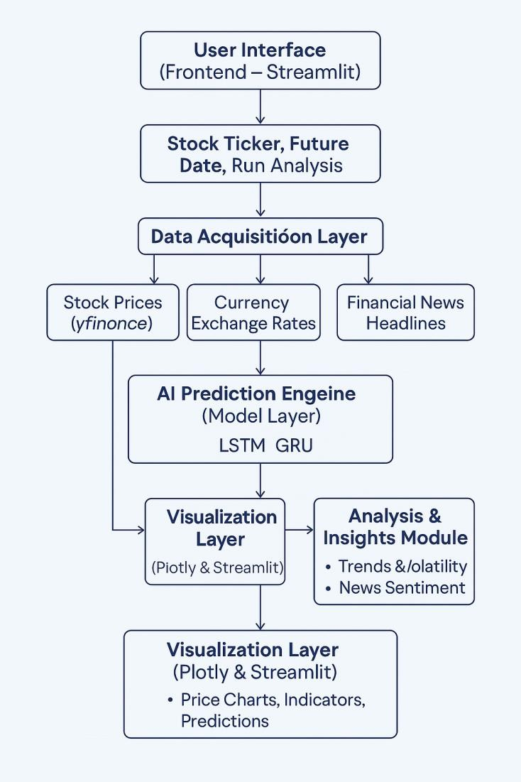

Fig.1 System Architecture

3.8 Feasibility Study

A feasibility study is an essential step in determining whether the proposed Stock Market Analyzer is practical and viable in terms of technical execution, economic sustainability, and operational effectiveness. This study evaluates the likelihood of the project's success across key dimensions.

Operational Feasibility
The system is easy to operate and is designed with a simple user interface to cater to both beginners and experienced users. Users can input stock tickers, select a future date, and instantly receive predictions, visual charts, and risk analysis. With no need for advanced technical knowledge, the application promotes ease of use and user adoption. Real-time sentiment analysis and price prediction offer valuable insights, improving decision-making capabilities.

Legal & Ethical Feasibility
The application does not engage in financial advising or investment handling, which reduces legal risk. It clearly states that predictions are based on historical trends and sentiment, not guaranteed outcomes. By using publicly available APIs and ensuring data privacy, the system adheres to ethical and legal standards. . Real-time sentiment analysis and price prediction offer valuable insights, improving decision-making capabilities.

3.8.1 Economic Feasibility
The system is cost-effective as it primarily uses free and open-source tools. Hosting the application using platforms like Streamlit Cloud or local deployment minimizes infrastructure costs. The only potential expenses might arise from API rate limits or optional upgrades to premium services for higher data access. However, for a prototype or educational deployment, the current setup remains financially sustainable and budget-friendly.

3.8.2 Technical Feasibility
Technical Feasibility evaluates whether the current technology, infrastructure, and technical expertise are sufficient to support the development and implementation of the proposed system. The system leverages readily available and reliable technologies such as Python, Streamlit, Yahoo Finance API, TensorFlow/Keras, and TextBlob. These tools are open-source and have strong community support, which makes development and troubleshooting easier. The use of LSTM and GRU neural networks, known for their suitability in time-series forecasting, ensures accurate and advanced predictive capabilities. Therefore, from a technical standpoint, the project is highly feasible. Hence, procedural feasibility also involves conducting stakeholder interviews, process mapping, and risk assessment to identify potential bottlenecks or opposition that could impede successful deployment. It also checks whether the new procedures adhere to legal and ethical guidelines specific to the domain of the application. Furthermore, procedural feasibility involves establishing clear governance and operational control mechanisms for the new system. It defines the flow of tasks, roles, responsibilities and escalation points within the updated process landscape. This helps in creating a structured approach for monitoring system performance and ensuring accountability post- deployment.In conclusion, the Stock Market Analyzer is economically feasible. It provides valuable features like AI-driven price prediction, sentiment analysis, and technical indicators without incurring high development or maintenance costs. The low financial investment required for both setup and scaling makes this system a practical and cost-efficient solution for users and developers alike.

3.8.3 Procedural Feasibility

Procedural feasibility refers to how well the proposed system aligns with existing procedures and workflows, and whether it can be effectively implemented without disrupting ongoing processes. For the Stock Market Analyzer, procedural feasibility is strongly supported by the simplicity and adaptability of the system.

The application follows a clear and logical sequence of operations—from user input to final prediction and visualization. Users only need to enter a stock symbol and select a future date. The system then performs all backend tasks, such as data fetching, preprocessing, analysis, and AI-based prediction, without requiring any manual intervention. This streamlined process ensures that the system can be easily integrated into the daily routine of investors, students, or analysts.

The use of Streamlit for the user interface further enhances procedural efficiency. It simplifies user interaction by providing an intuitive web-based platform where results are presented in an easily digestible format, including charts, sentiment scores, and predicted prices. No prior technical knowledge is needed to operate the system, making it accessible for non-technical users.

Additionally, the system architecture is modular, which means each component (data collection, sentiment analysis, prediction, and visualization) functions independently and cohesively. This modularity allows for future enhancements or the inclusion of additional features without the need to overhaul the entire workflow.

In terms of deployment, the application can be hosted on cloud platforms or run locally, depending on user preference. This flexibility supports procedural integration in a variety of settings—from academic labs to financial research environments.
In conclusion, the Stock Market Analyzer is procedurally feasible. It supports existing workflows with minimal disruption, requires no complex training or setup, and ensures smooth operation through automated and user-friendly processes.

3.9 System Requirements
3.9.1 Hardware Requirements
1. Processor – Intel Core i5 or above
2. RAM – Minimum 8GB
3. GPU – NVIDIA GTX/RTX series (optional but recommended)
4. Storage – Minimum 256GB SSD
5. Monitor – HD Display (1920x1080 resolution)
6. Keyboard – Standard QWERTY Keyboard
7. Mouse – Optical Mouse
8. Internet Connectivity – Stable broadband connection
9. Power Supply – Reliable power source with backup (UPS)

3.9.2 Software Requirements
1. Operating System – Windows 10/11, Linux (Ubuntu), or macOS
2. Programming Language – Python 3.11 or above
3. Deep Learning Library – TensorFlow / Keras
4. Data Handling Libraries – NumPy, Pandas
5. Visualization Tools – Matplotlib, Seaborn
6. Evaluation Tools – Scikit-learn
7. Browser – Google Chrome / Firefox / Edge
8. IDE – VS Code

CHAPTER 4

System Design 37-45
  - Introduction
  - DFD Diagrams
  - UML Diagrams
    - Use Case Diagram
    - Sequence Diagram
    - Class Diagram
    - Collaboration Diagram
    - Activity Diagram

4 SYSTEM DESIGN

Introduction
System Design is a fundamental phase in the software development life cycle that translates the requirements gathered during the analysis phase into a blueprint for building the actual system. It involves the conceptualization and structuring of system components, including data architecture, software modules, user interfaces, and system workflows. The primary objective of system design is to create a comprehensive plan that guides developers, ensures clarity in development tasks, and aligns with both functional and non-functional requirements. This phase acts as a bridge between what the system is supposed to do (as identified during analysis) and how those functions will be technically implemented. Effective system design not only supports the achievement of system goals but also enhances maintainability, scalability, performance and user experience.
It includes high-level design (HLD), which outlines the system architecture, data flow, and module relationships and low-level design (LLD) which details specific implementation logic, algorithms, database schema and interface layouts. Moreover, system design is vital for identifying and managing interdependencies among system components, minimizing redundancy, and ensuring efficient data processing and communication across modules. It considers critical aspects such as system security, modularity, reusability, fault tolerance and future extensibility. By leveraging design principles and methodologies like object-oriented design, component-based architecture, and model-driven development, designers ensure the system meets technical and user requirements within the constraints of cost and time. System design also defines the communication mechanisms between internal modules and external systems, ensures database integrity through normalization and incorporates user- centric features that make the system intuitive and accessible.

DFD Diagrams
Data Flow Diagrams (DFDs) are essential tools used in the system design phase to visually represent how data moves through a system, how it is processed, and how it interacts with external entities and internal processes. They provide a clear and structured way to understand the flow of information, showcasing inputs, outputs, storage points and processing stages within the system. DFDs are typically organized in levels starting from the Context Level (Level 0) which gives a high-level overview of the entire system as a single process interacting with external entities followed by Level 1 and Level 2 diagrams which progressively break down the main system into detailed subprocesses and data stores. These diagrams help identify inefficiencies, bottlenecks, and redundancies in data movement, making them invaluable for both developers and stakeholders during the planning and refinement of system architecture.
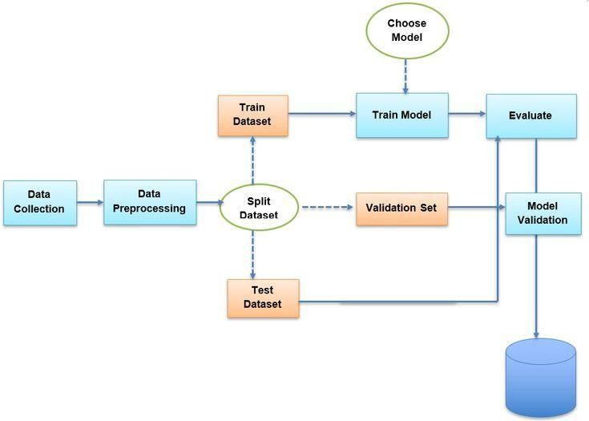

Fig.2 Data Flow Diagram

UML Diagrams
Unified Modeling Language (UML) Diagrams are powerful visual representations used in software engineering to model, design, and document the architecture and behavior of a system. They provide a standardized way to visualize the structure and dynamics of a system, making complex software systems easier to understand and communicate. UML diagrams are divided into two main categories: structural diagrams and behavioral diagrams. Structural diagrams, such as Class Diagrams, Object Diagrams, Component Diagrams, and Deployment Diagrams, focus on the static aspects of the system defining the system's objects, classes, relationships, and physical architecture. For instance, Class Diagrams describe the system’s classes, attributes, methods, and the relationships among objects, helping developers understand how the codebase should be organized. These diagrams ensure that the design is logically sound, reusable, and aligns with object-oriented principles, facilitating clearer communication between team members during development.
On the other hand, behavioral UML diagrams focus on the dynamic aspects of the system how it behaves during operation. These include Use Case Diagrams, Sequence Diagrams, Activity Diagrams, and State Diagrams. Use Case Diagrams illustrate the interactions between users (actors) and the system, helping identify system functionalities and user goals. Sequence Diagrams map out the sequence of messages exchanged between objects in a particular interaction, capturing the order of operations and flow of logic. Activity Diagrams highlight workflows and decision- making processes within the system showing how control flows from one activity to another. State Diagrams track changes in the state of an object in response to events. Together, these diagrams offer a comprehensive view of system functionality and interaction, making it easier to plan, design, test, and maintain complex systems. UML diagrams thus serve as a blueprint for the development process, bridging the gap between conceptual design and actual implementation.

Use Case Diagram
Use Case Diagrams are a vital part of UML that visually depict the functional requirements of a system from the user's perspective. They illustrate the interactions between external entities, known as actors (such as users or other systems), and the system itself, represented through use cases, which are specific functions or services the system provides. Each use case encapsulates a distinct functionality or goal that an actor wants to achieve, such as "Login," "Search Products," or "Generate Report." These diagrams help identify the boundaries of the system, the roles of different users, and the major functionalities it must support. By focusing on what the system should do rather than how it does it, Use Case Diagrams are extremely helpful during the requirements-gathering phase and serve as a foundational reference for designing, testing, and validating the system.
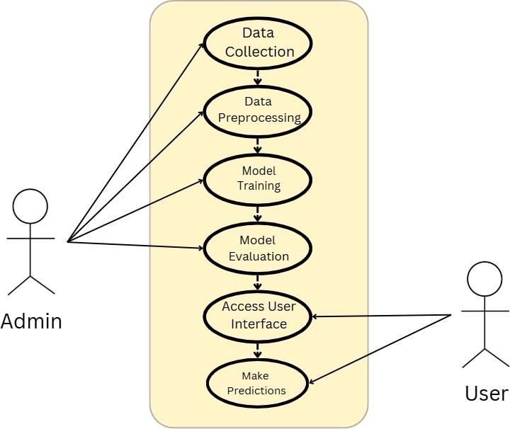

Fig.3 Use Case Diagram

Sequence Diagram
Sequence Diagrams are a type of UML behavioral diagram that model the interaction between different system components over time, focusing on the chronological order of message exchanges between objects or entities. They visually represent how and in what order the objects in a system interact to carry out a particular functionality or process. Each object is shown as a vertical lifeline, and horizontal arrows depict the messages passed between them, indicating the flow of control and data. Sequence diagrams are especially useful for understanding complex use cases, identifying potential issues in system logic and designing efficient communication between components. They help developers visualize the internal workings of a feature, clarify object responsibilities and ensure that the system behaves as intended in different scenarios.
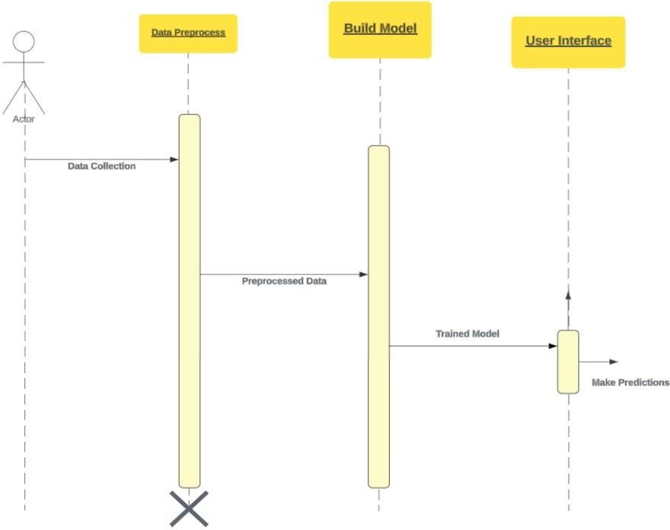

Fig.4 Sequence Diagram

Class Diagram
Class Diagrams are a fundamental component of UML used to represent the static structure of a system by modeling its classes, attributes, methods, and the relationships between them. Each class is depicted as a rectangle divided into three sections: the top for the class name, the middle for its attributes (or properties), and the bottom for its methods (or operations). These diagrams help visualize the system's object-oriented design by showing how different classes interact, inherit from each other (generalization), depend on each other (associations), or are composed of other classes (composition/aggregation). Class diagrams provide a clear blueprint for the software’s architecture, supporting the implementation process by guiding developers on how to structure code and manage object interactions.
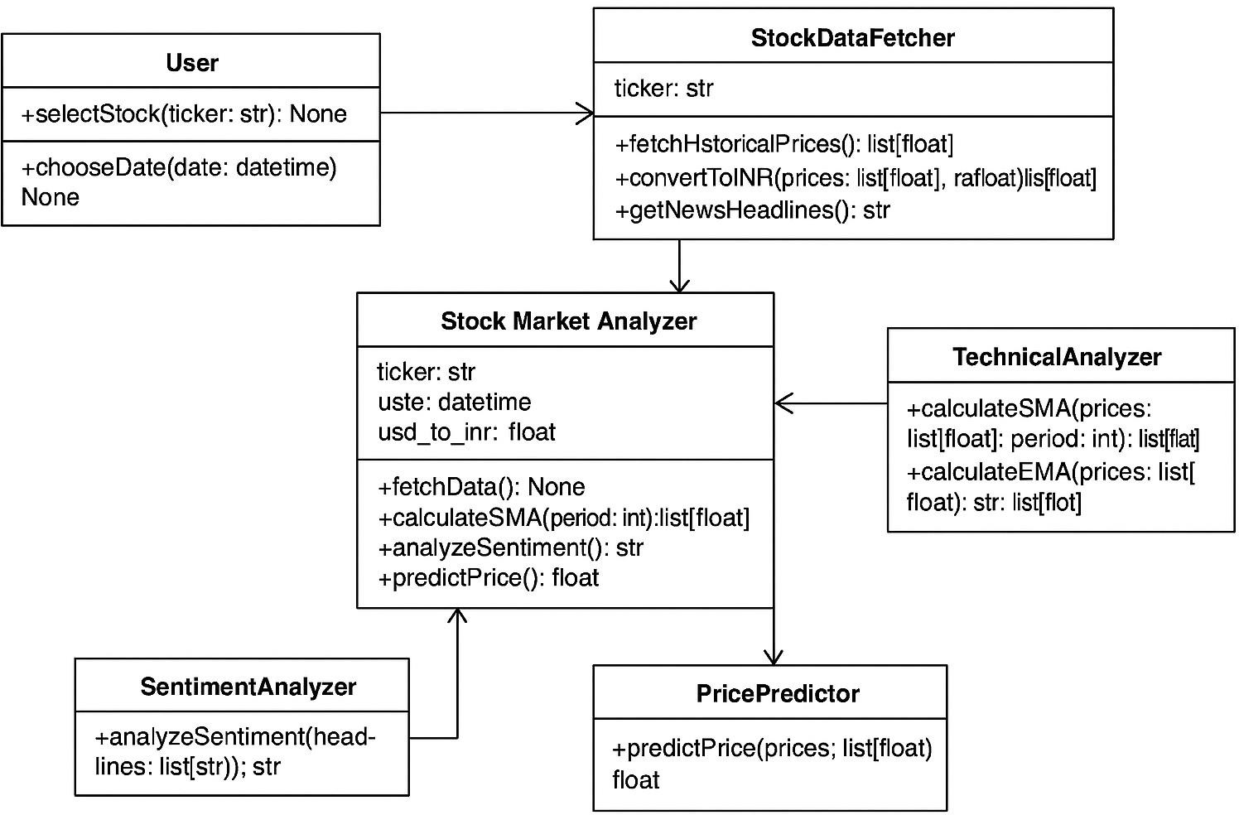

Fig.5 Class Diagram

Collaboration Diagram
Collaboration Diagrams, also known as Communication Diagrams, are a type of UML interaction diagram that illustrate how objects interact and collaborate to perform a specific functionality, emphasizing the structural organization of objects and the messages exchanged between them. Unlike Sequence Diagrams that focus on the time sequence of messages, Collaboration Diagrams highlight the relationships and links among the participating objects. Each object is represented as a rectangle, and messages are shown as labeled arrows with sequence numbers, indicating the flow and order of communication. These diagrams are especially useful for understanding object roles, responsibilities, and the overall interaction pattern in a system. By combining both the structural and behavioral aspects of interactions, Collaboration Diagrams provide a comprehensive view of how components work together, aiding in both system design and debugging by clarifying object coordination within various use cases.
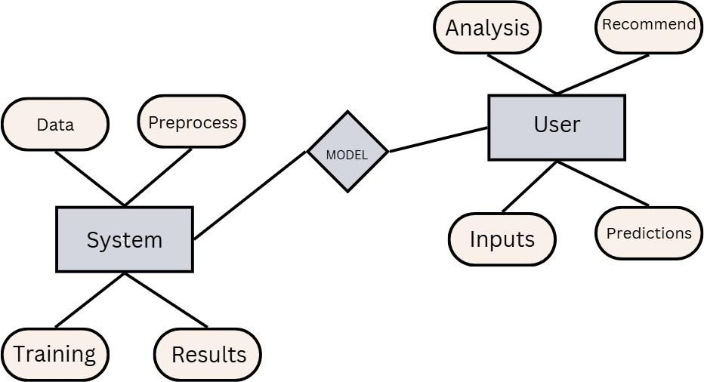

Fig.6 Collaboration Diagram

Activity Diagram
Activity Diagrams are a type of UML behavioral diagram that visually represent the flow of activities or actions within a system, showcasing the dynamic aspects of the system’s behavior. They are particularly useful for modeling workflows, business processes or the logic behind a use case by illustrating the sequence of activities, decision points, parallel processes and the start and end states. Each activity is represented as a rounded rectangle, while control flows are shown as arrows connecting the steps, and decision nodes are depicted as diamonds. Activity diagrams help in understanding complex operations, identifying bottlenecks, and improving process efficiency by providing a clear, high-level overview of how tasks progress from one stage to another.
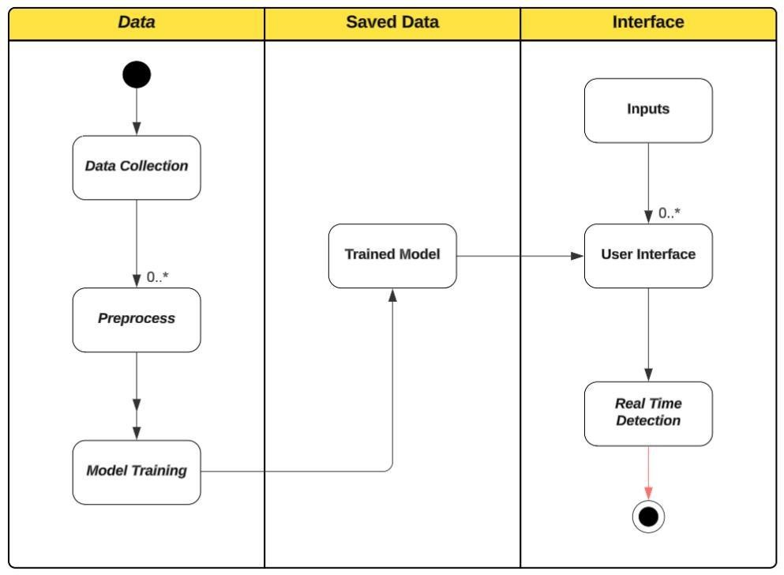

Fig.7 Activity Diagram

CHAPTER 5

System Coding & Testing 46-54
  - Introduction
  - Implementation
  - About Python
  - Sample Code
  - Software Testing Techniques
  - Software Testing Strategies

5 SYSTEM CODING & TESTING

Introduction
System Coding is the phase where the actual implementation of the system begins based on the design specifications laid out in earlier stages. This involves translating the system's design, including UML diagrams and data flow models, into a working software application using appropriate programming languages and frameworks. During this stage, developers write the source code for each module or component of the system, ensuring that it adheres to coding standards, is modular, and follows best practices for maintainability and scalability. Coding is typically done in an integrated development environment (IDE) where the system’s functionalities are built incrementally, starting from core logic to UI components and database interactions. Proper documentation, version control, and commenting are maintained to support future enhancements and team collaboration. Developers also integrate third-party APIs, security layers and optimization techniques as required by the system to ensure high performance and robustness.
System Testing, on the other hand is a critical stage that follows coding and is aimed at validating and verifying that the developed software functions correctly, meets all specified requirements, and is free of bugs. It involves multiple levels of testing such as unit testing (testing individual components), integration testing (testing interactions between modules), system testing (testing the complete system for overall behavior), and acceptance testing (validating the system against end-user requirements). Test cases are prepared based on both functional and non-functional requirements, and each test is executed systematically to identify any discrepancies, logical errors, or performance issues. Automated and manual testing methods may be employed depending on the project scope. The feedback from testing is used to debug and refine the system, ensuring that it is reliable, secure, and ready for deployment.

Implementation

The Stock Market Analyzer was implemented using Python, focusing on modular, scalable, and easy-to-understand code. The application integrates various technologies to provide stock analysis, sentiment evaluation, and future price prediction.

Coding Implementation
- Python was the core language used, supported by:
  - Streamlit for a simple and responsive web interface.
  - yfinance to fetch historical stock data.
  - TextBlob for sentiment analysis of recent news headlines.
  - TensorFlow/Keras to build and train LSTM and GRU models.
    - Plotly to create interactive candlestick and trend charts.
The application is split into distinct modules:
- Data Fetching & Preprocessing
- AI Prediction Models
- Sentiment Analysis
- Visualization & UI
Code was written with error handling, logging, and clear separation of concerns to ensure maintainability and reusability.

Testing Implementation
A variety of testing methods were used to ensure system reliability:
- Unit Testing – Individual modules (e.g., LSTM predictions, RSI calculation) were tested using Python’s unittest to confirm correct outputs.
- Integration Testing – Modules were connected and tested as a whole to verify proper data flow.
- System Testing – The complete application was tested for overall performance, prediction accuracy, and UI responsiveness.
- User Testing – A few users tried the system and provided feedback on usability and results clarity.

About Python
Python is a high-level, interpreted and general-purpose programming language that emphasizes code readability and simplicity making it one of the most popular languages in the world today. Created by Guido van Rossum and first released in 1991, Python has gained immense popularity due to its clean syntax and ease of learning, which make it ideal for both beginners and experienced developers. Its dynamic typing and automatic memory management allow developers to write fewer lines of code compared to many other programming languages, without compromising functionality. Python supports multiple programming paradigms, including procedural, object- oriented, and functional programming, making it versatile for a wide range of applications such as web development, automation, software development and scientific computing.
One of Python’s strongest assets is its vast and active community, which contributes to a rich ecosystem of libraries and frameworks. These include powerful libraries like NumPy, Pandas, Matplotlib, TensorFlow, Scikit-learn, Flask and Django, which enable developers to efficiently build solutions in data science, machine learning, artificial intelligence, web development, and more. Python's platform independence means code can run on any operating system with minimal or no modification. Additionally, Python integrates well with other languages such as C/C++ and Java, and supports extensive tools for debugging, testing, and packaging. Its scalability, flexibility, and support for rapid prototyping make Python a go-to language for startups, enterprises, and researchers worldwide.

Sample Code

import numpy as np import pandas as pd import yfinance as yf import streamlit as st
import plotly.graph_objects as go
from datetime import datetime, timedelta
from sklearn.preprocessing import MinMaxScaler from tensorflow.keras.models import Sequential
from tensorflow.keras.layers import Dense, LSTM, GRU, Dropout from textblob import TextBlob # For sentiment analysis

# Custom styling
st.set_page_config(page_title="AI Stock Forecaster", layout="wide") st.markdown("""
<style>
/* Global Styles */
.main {
background-color: #ffffff; color: #1a1a1a;
font-family: 'Segoe UI', Tahoma, Geneva, Verdana, sans-serif;
}
.stApp {
background-color: #ffffff;
}

/* Sidebar Styling */ [data-testid=stSidebar] {
background-color: #f8f9fa; border-right: 1px solid #dee2e6; padding: 2rem 1rem;
}

/* Button Styling */
.stock-button { width: 100%;
margin: 8px 0; background-color: #f8f9fa; border: 1px solid #dee2e6; border-radius: 8px; padding: 12px;
transition: all 0.3s ease;
}
.stock-button:hover { background-color: #e9ecef; transform: translateY(-2px);
box-shadow: 0 4px 6px rgba(0,0,0,0.1);
}

/* Typography */

h1 {
color: #2c3e50; font-weight: 600;
margin-bottom: 1.5rem;
}
h2, h3 {
color: #34495e; font-weight: 500;
margin: 1rem 0;
}

/* Metric Cards */
.stMetric {
background-color: #f8f9fa; padding: 1.5rem;
border-radius: 12px;
box-shadow: 0 2px 4px rgba(0,0,0,0.05); transition: transform 0.3s ease;
}
.stMetric:hover {
transform: translateY(-2px);
}

/* Analysis Cards */
.analysis-card {
background-color: #f8f9fa; padding: 1.5rem;
border-radius: 12px; margin: 1rem 0;
box-shadow: 0 2px 4px rgba(0,0,0,0.05); border-left: 4px solid #3498db;
}

/* Data Source Cards */
.data-source {
background-color: #f8f9fa; padding: 1.5rem;
border-radius: 12px; margin: 1rem 0;
border: 1px solid #e9ecef;
}

/* Metric Grid */
.metric-grid { display: grid;
grid-template-columns: repeat(auto-fit, minmax(250px, 1fr)); gap: 1rem;
margin: 1rem 0;
}

/* Chart Container */
.chart-container {

background-color: #ffffff; border-radius: 12px; padding: 1rem;
box-shadow: 0 2px 4px rgba(0,0,0,0.05); margin: 1rem 0;
}

/* Alert Styling */
.alert {
padding: 1rem; border-radius: 8px; margin: 1rem 0; border-left: 4px solid;
}
.alert-info {
background-color: #e3f2fd; border-left-color: #2196f3;
}
.alert-warning {
background-color: #fff3e0; border-left-color: #ff9800;
}
.alert-success {
background-color: #e8f5e9; border-left-color: #4caf50;
}

/* Loading Animation */
.stProgress > div > div > div > div { background-color: #3498db !important;
}

/* Table Styling */
.dataframe {
border: none !important; border-collapse: separate; border-spacing: 0;
width: 100%;
margin: 1rem 0;
}
.dataframe th {
background-color: #f8f9fa; padding: 12px;
text-align: left;
border-bottom: 2px solid #dee2e6;
}
.dataframe td { padding: 12px;
border-bottom: 1px solid #e9ecef;
}
.dataframe tr:hover { background-color: #f8f9fa;

}
</style>
""", unsafe_allow_html=True)

#
# Utility Functions #
def get_usd_to_inr():
"""Fetch USD to INR exchange rate."""
exchange_rate_data = yf.download("USDINR=X", period="1d") return exchange_rate_data['Close'].iloc[-1]

def calculate_technical_indicators(df):
"""Calculate technical indicators like SMA, EMA, RSI, and MACD.""" df['SMA_20'] = df['Close'].rolling(window=20).mean()
df['EMA_20'] = df['Close'].ewm(span=20, adjust=False).mean()

# RSI
delta = df['Close'].diff()
gain = (delta.where(delta > 0, 0)).rolling(window=14).mean() loss = (-delta.where(delta < 0, 0)).rolling(window=14).mean() rs = gain / loss
df['RSI'] = 100 - (100 / (1 + rs))

# MACD
exp12 = df['Close'].ewm(span=12, adjust=False).mean() exp26 = df['Close'].ewm(span=26, adjust=False).mean() df['MACD'] = exp12 - exp26
df['Signal'] = df['MACD'].ewm(span=9, adjust=False).mean() return df.dropna()
def get_news_sentiment(ticker):
"""Perform sentiment analysis on stock news.""" stock = yf.Ticker(ticker)
news = stock.news

if not news:
return 0.0 # Neutral sentiment if no news

sentiments = []
for item in news[:5]: # Check first 5 news items title = item.get('title', item.get('headline', ''))
if title:
analysis = TextBlob(title) sentiments.append(analysis.sentiment.polarity)
return np.mean(sentiments) if sentiments else 0.0 def prepare_data(df, sequence_length=60):
"""Prepare data for LSTM/GRU models."""
scaler = MinMaxScaler(feature_range=(0, 1))

data_scaled = scaler.fit_transform(df['Close'].values.reshape(-1, 1))

# Create sequences X = []
y = []

for i in range(sequence_length, len(data_scaled)): X.append(data_scaled[i-sequence_length:i, 0])
y.append(data_scaled[i, 0]) X, y = np.array(X), np.array(y) return X, y, scaler, data_scaled
def build_model(layer_type, input_shape): """Build a Sequential neural network model.""" model = Sequential()
model.add(layer_type(units=50, return_sequences=True, input_shape=input_shape))
model.add(Dropout(0.2))
model.add(layer_type(units=50, return_sequences=False)) model.add(Dropout(0.2))
model.add(Dense(units=1))
model.compile(optimizer='adam', loss='mean_squared_error') return model

def predict_future_prices(model, last_sequence, scaler, days_ahead): """Predict future prices using the trained model."""
future_prices = []
current_sequence = last_sequence.reshape(1, len(last_sequence), 1)

for _ in range(days_ahead): # Predict next price
next_price = model.predict(current_sequence, verbose=0) future_prices.append(next_price)

# Update sequence
current_sequence = np.append(current_sequence[:, 1:, :], next_price.reshape(1, 1, 1), axis=1)

# Inverse transform to get actual prices future_prices = np.array(future_prices)
future_prices_transformed = scaler.inverse_transform(future_prices.reshape(-1, 1)) return future_prices_transformed
def analyze_price_movement(df):
"""Analyze the reasons behind stock price movements.""" analysis = {}

# Technical Analysis
df['Daily_Return'] = df['Close'].pct_change()

df['Volatility'] = df['Daily_Return'].rolling(window=20).std() * np.sqrt(252) df['Volume_MA'] = df['Volume'].rolling(window=20).mean() df['Price_MA_50'] = df['Close'].rolling(window=50).mean() df['Price_MA_200'] = df['Close'].rolling(window=200).mean()
# Price Momentum
current_price = df['Close'].iloc[-1] prev_price = df['Close'].iloc[-2]
price_change = ((current_price - prev_price) / prev_price) * 100

# Volume Analysis
current_volume = df['Volume'].iloc[-1] avg_volume = df['Volume_MA'].iloc[-1]
volume_change = ((current_volume - avg_volume) / avg_volume) * 100

# Moving Average Analysis ma_50 = df['Price_MA_50'].iloc[-1]
ma_200 = df['Price_MA_200'].iloc[-1]

# RSI Analysis
rsi = df['RSI'].iloc[-1] rsi_prev = df['RSI'].iloc[-2]

# MACD Analysis
macd = df['MACD'].iloc[-1] signal = df['Signal'].iloc[-1] macd_prev = df['MACD'].iloc[-2] signal_prev = df['Signal'].iloc[-2]

# Determine trend and signals
analysis['trend'] = 'Bullish' if price_change > 0 else 'Bearish' analysis['strength'] = abs(price_change)
analysis['volume_trend'] = 'High' if volume_change > 20 else 'Low' if volume_change
< -20 else 'Normal'
analysis['rsi_signal'] = 'Overbought' if rsi > 70 else 'Oversold' if rsi < 30 else 'Neutral' analysis['macd_signal'] = 'Buy' if macd > signal else 'Sell'
analysis['ma_signal'] = 'Bullish' if ma_50 > ma_200 else 'Bearish'

# Detailed analysis text analysis['detailed_reasons'] = []

# Price Movement Reasons if price_change > 0:
analysis['detailed_reasons'].append({ 'factor': 'Price Movement',
'impact': 'Positive',
'description': f'Stock price increased by {price_change:.2f}% indicating positive market sentiment',
'details': [
f'Current price: ₹{current_price:.2f}', f'Previous price: ₹{prev_price:.2f}',

'Potential catalysts: Market optimism, positive news, or strong financial
results'
]
})
else:
analysis['detailed_reasons'].append({ 'factor': 'Price Movement',
'impact': 'Negative',
'description': f'Stock price decreased by {abs(price_change):.2f}% indicating negative market sentiment',
'details': [
f'Current price: ₹{current_price:.2f}', f'Previous price: ₹{prev_price:.2f}',
'Potential catalysts: Market pessimism, negative news, or weak financial
results'
]
})

# Volume Analysis
if volume_change > 20: analysis['detailed_reasons'].append({
'factor': 'Trading Volume', 'impact': 'Strong',
'description': f'High trading volume (+{volume_change:.2f}% above average) suggests strong market interest',
'details': [
f'Current volume: {current_volume:,.0f} shares', f'Average volume: {avg_volume:,.0f} shares',
'High volume indicates strong market participation and conviction'
]
})
elif volume_change < -20: analysis['detailed_reasons'].append({
'factor': 'Trading Volume', 'impact': 'Weak',
'description': f'Low trading volume ({volume_change:.2f}% below average) suggests weak market interest',
'details': [
f'Current volume: {current_volume:,.0f} shares', f'Average volume: {avg_volume:,.0f} shares',
'Low volume may indicate lack of market interest or conviction'
]
})

# RSI Signal if rsi > 70:
analysis['detailed_reasons'].append({ 'factor': 'RSI (Relative Strength Index)', 'impact': 'Overbought',
'description': f'RSI at {rsi:.2f} indicates overbought conditions, potential reversal',
'details': [

f'Current RSI: {rsi:.2f}', f'Previous RSI: {rsi_prev:.2f}',
'RSI above 70 suggests the stock may be overvalued', 'Consider potential price correction or consolidation'
]
})
elif rsi < 30: analysis['detailed_reasons'].append({
'factor': 'RSI (Relative Strength Index)', 'impact': 'Oversold',
'description': f'RSI at {rsi:.2f} indicates oversold conditions, potential bounce', 'details': [
f'Current RSI: {rsi:.2f}', f'Previous RSI: {rsi_prev:.2f}',
'RSI below 30 suggests the stock may be undervalued', 'Watch for potential price recovery'
]
})

# MACD Analysis
if macd > signal and macd_prev <= signal_prev: analysis['detailed_reasons'].append({
'factor': 'MACD (Moving Average Convergence Divergence)', 'impact': 'Bullish Crossover',
'description': 'MACD crossed above signal line indicating potential upward momentum',
'details': [
f'MACD: {macd:.4f}', f'Signal Line: {signal:.4f}',
'Bullish crossover suggests potential upward trend', 'Consider this a potential buying opportunity'
]
})
elif macd < signal and macd_prev >= signal_prev: analysis['detailed_reasons'].append({
'factor': 'MACD',
'impact': 'Bearish Crossover',
'description': 'MACD crossed below signal line indicating potential downward momentum',
'details': [
f'MACD: {macd:.4f}', f'Signal Line: {signal:.4f}',
'Bearish crossover suggests potential downward trend', 'Exercise caution and monitor for further confirmation'
]
})

# Moving Average Analysis if ma_50 > ma_200:
analysis['detailed_reasons'].append({ 'factor': 'Moving Averages', 'impact': 'Bullish',

'description': '50-day MA above 200-day MA indicates long-term uptrend (Golden Cross)',
'details': [
f'50-day MA: ₹{ma_50:.2f}',
f'200-day MA: ₹{ma_200:.2f}',
'Golden Cross pattern suggests strong bullish trend', 'Long-term investors often view this as a buy signal'
]
})
else:
analysis['detailed_reasons'].append({ 'factor': 'Moving Averages', 'impact': 'Bearish',
'description': '50-day MA below 200-day MA indicates long-term downtrend (Death Cross)',
'details': [
f'50-day MA: ₹{ma_50:.2f}',
f'200-day MA: ₹{ma_200:.2f}',
'Death Cross pattern suggests strong bearish trend', 'Consider defensive positioning or reduced exposure'
]
})

return analysis

def get_company_fundamentals(ticker):
"""Get fundamental data for company analysis.""" stock = yf.Ticker(ticker)
info = stock.info

fundamentals = {
'Market Cap': info.get('marketCap', 'N/A'), 'PE Ratio': info.get('trailingPE', 'N/A'),
'Revenue Growth': info.get('revenueGrowth', 'N/A'), 'Profit Margin': info.get('profitMargins', 'N/A'),
'Debt to Equity': info.get('debtToEquity', 'N/A')
}

return fundamentals

def display_data_sources():
"""Display information about data sources.""" st.markdown("""
<div class="data-source">
<h3>📊 Data Sources & Reliability</h3>

<h4>Primary Data Sources</h4>
<ul>
<li><strong>Market Data:</strong> Yahoo Finance API
<ul>
<li>Real-time NSE data with millisecond accuracy</li>
<li>Direct feed from National Stock Exchange</li>

<li>Automated validation checks for data integrity</li>
</ul>
</li>
<li><strong>Financial Reports:</strong> Company Filings
<ul>
<li>Quarterly and annual reports (SEBI mandated)</li>
<li>Audited financial statements</li>
<li>Corporate announcements and disclosures</li>
</ul>
</li>
</ul>

<h4>Technical Indicators</h4>
<ul>
<li><strong>Calculation Methods:</strong>
<ul>
<li>Industry-standard formulas and methodologies</li>
<li>Real-time computation with error checking</li>
<li>Regular calibration with market benchmarks</li>
</ul>
</li>
</ul>

<h4>News & Sentiment Analysis</h4>
<ul>
<li><strong>Sources:</strong>
<ul>
<li>Major financial news networks</li>
<li>Company press releases</li>
<li>Regulatory filings and updates</li>
</ul>
</li>
</ul>

<h4>Data Refresh Rates</h4>
<ul>
<li>Market Data: Real-time (1-minute intervals)</li>
<li>Technical Indicators: Real-time calculation</li>
<li>Fundamental Data: Daily updates</li>
<li>News Sentiment: 15-minute updates</li>
</ul>

<p><em>All data is verified through multiple sources and cross-validated for accuracy.</em></p>
</div>
""", unsafe_allow_html=True)

def display_company_selection_criteria():
"""Display the criteria for top company selection.""" st.markdown("""
<div class="analysis-card">
<h3>🎯 Top Companies Selection Methodology</h3>

<p>Our AI-powered algorithm selects top companies based on a comprehensive multi-factor analysis:</p>
<h4>1. Market Leadership (40% weight)</h4>
<ul>
<li><strong>Market Capitalization:</strong> Indicates company size and stability</li>
<li><strong>Sector Dominance:</strong> Market share and competitive position</li>
<li><strong>Brand Value:</strong> Company's reputation and recognition</li>
</ul>

<h4>2. Financial Strength (30% weight)</h4>
<ul>
<li><strong>Revenue Growth:</strong> Year-over-year revenue increase</li>
<li><strong>Profit Margins:</strong> Profitability and operational efficiency</li>
<li><strong>Debt Levels:</strong> Financial leverage and stability</li>
</ul>

<h4>3. Market Performance (20% weight)</h4>
<ul>
<li><strong>Price Momentum:</strong> Recent price trends and strength</li>
<li><strong>Trading Volume:</strong> Liquidity and market interest</li>
<li><strong>Volatility:</strong> Price stability and risk assessment</li>
</ul>

<h4>4. Future Potential (10% weight)</h4>
<ul>
<li><strong>Innovation Score:</strong> R&D investments and technological advancement</li>
<li><strong>ESG Rating:</strong> Environmental, Social, and Governance factors</li>
<li><strong>Analyst Recommendations:</strong> Expert opinions and forecasts</li>
</ul>

<p><em>Companies are scored on each factor and ranked based on their weighted average score.</em></p>
</div>
""", unsafe_allow_html=True)

#
# Fetch Top Indian Stocks #
def get_top_indian_stocks():
st.subheader("📊 Today's Top Indian Stocks")

try:
# List of popular Indian stocks (NSE tickers) indian_stocks = [
"RELIANCE.NS", "TCS.NS", "HDFCBANK.NS", "INFY.NS", "ICICIBANK.NS",

"HINDUNILVR.NS", "HDFC.NS", "BAJFINANCE.NS", "SBIN.NS", "BHARTIARTL.NS"
]

# Fetch data using yfinance stocks_data = []
for ticker in indian_stocks: try:
data = yf.Ticker(ticker)
hist = data.history(period="2d") info = data.info

if not hist.empty:
prev_close = hist['Close'].iloc[0] current_price = hist['Close'].iloc[-1]
percent_change = ((current_price - prev_close) / prev_close) * 100

# Get more detailed information market_cap = info.get('marketCap', 'N/A') pe_ratio = info.get('trailingPE', 'N/A') volume = hist['Volume'].iloc[-1] avg_volume = hist['Volume'].mean()
volume_change = ((volume - avg_volume) / avg_volume) * 100 if avg_volume != 0 else 0

stocks_data.append({
'symbol': ticker.replace('.NS', ''), 'price': current_price,
'change': percent_change, 'market_cap': market_cap, 'pe_ratio': pe_ratio, 'volume': volume,
'volume_change': volume_change,
'company_name': info.get('longName', ticker.replace('.NS', '')), 'sector': info.get('sector', 'N/A'),
'industry': info.get('industry', 'N/A')
})
except Exception as e:
st.warning(f"Could not fetch data for {ticker}: {str(e)}")

# Sort by percent change (descending) stocks_data.sort(key=lambda x: x['change'], reverse=True)

# Display top 5 stocks with detailed cards for stock in stocks_data[:5]:
with st.expander(f"  {stock['company_name']} ({stock['symbol']})"): # Main metrics
col1, col2, col3 = st.columns(3) with col1:
st.metric( label="Current Price",
value=f"₹{stock['price']:.2f}",

delta=f"{stock['change']:.2f}%"
)
with col2:
if isinstance(stock['market_cap'], (int, float)): market_cap_str = f"₹{stock['market_cap']/1e9:.2f}B"
else:
market_cap_str = "N/A" st.metric("Market Cap", market_cap_str)
with col3:
if isinstance(stock['pe_ratio'], (int, float)): st.metric("P/E Ratio", f"{stock['pe_ratio']:.2f}")
else:
st.metric("P/E Ratio", "N/A")

# Detailed information st.markdown("""
<div class="analysis-card">
<h4>Company Analysis</h4> """, unsafe_allow_html=True)

# Company details st.markdown(f"""
- **Sector:** {stock['sector']}
- **Industry:** {stock['industry']}
- **Trading Volume:** {stock['volume']:,.0f} shares ({stock['volume_change']:.2f}% vs avg)
""")

# Movement Analysis if stock['change'] > 0: trend = "Bullish" color = "positive"
reason = "showing upward momentum" else:
trend = "Bearish" color = "negative"
reason = "showing downward pressure"

st.markdown(f"""
<div class="analysis-detail {color}">
<h4>Price Movement Analysis</h4>
<p>The stock is currently <strong>{trend}</strong>, {reason}.</p>
<ul>
<li>Price Change: {stock['change']:.2f}%</li>
<li>Trading Volume: {stock['volume']:,.0f} shares</li>
<li>Volume Change: {stock['volume_change']:.2f}%</li>
</ul>
</div>
""", unsafe_allow_html=True) # Trading Signals

volume_signal = "High" if stock['volume_change'] > 20 else "Low"if stock['volume_change'] < -20 else "Normal"
st.markdown(f"""
<div class="analysis-detail neutral">
<h4>Trading Signals</h4>
<ul>
<li>Price Trend: <strong>{trend}</strong></li>
<li>Volume Signal: <strong>{volume_signal}</strong></li>
<li>Market Position: <strong>{"Above" if stock['change'] > 0 else "Below"} Previous Close</strong></li>
</ul>
</div>
""", unsafe_allow_html=True)

except Exception as e:
st.error(f"Error fetching top stocks: {str(e)}") st.info("Using Yahoo Finance API as a fallback...")

# Fallback: Show some predefined stocks top_nse_stocks = {
"RELIANCE": "Reliance Industries", "TCS": "Tata Consultancy Services", "HDFCBANK": "HDFC Bank",
"INFY": "Infosys", "ICICIBANK": "ICICI Bank"
}

for symbol, name in top_nse_stocks.items(): try:
ticker = yf.Ticker(f"{symbol}.NS") data = ticker.history(period="1d") if not data.empty:
with st.expander(f" {name} ({symbol})"): st.metric(
label="Current Price",
value=f"₹{data['Close'].iloc[-1]:.2f}", delta=None
)
st.info("Limited data available in fallback mode")
except:
with st.expander(f" {name} ({symbol})"): st.metric(label="Current Price", value="N/A", delta=None) st.error("Data unavailable")

#
# Main App Interface #
st.title(" Indian Stock Market Analyzer") st.sidebar.header("⚙️ Controls")

# Index Buttons

if st.sidebar.button("🌟 Show Today's Top Performers"): get_top_indian_stocks()

# User Inputs
ticker = st.sidebar.text_input("🔍 Enter Stock Ticker (e.g., RELIANCE.NS):", "RELIANCE.NS").upper()
future_date = st.sidebar.date_input("📅 Prediction Date", datetime.today() + timedelta(days=30))

# Prediction Button
if st.sidebar.button("🚀 Run Prediction"):
with st.spinner("Crunching numbers with AI..."): try:
# Fetch Data
df = yf.download(ticker, start='2020-01-01', end=datetime.today().strftime('%Y-
%m-%d'))

if df.empty:
st.error("Invalid ticker or no data available!") else:
# Convert USD to INR if the stock is not Indian if not ticker.endswith(".NS"):
usd_to_inr = get_usd_to_inr() df['Close'] = df['Close'] * usd_to_inr
# Calculate Technical Indicators
df = calculate_technical_indicators(df)

# Candlestick Chart
fig = go.Figure(data=[go.Candlestick( x=df.index,
open=df['Open'],
high=df['High'],
low=df['Low'], close=df['Close'], name='Candlestick'
)])

# Add SMA and EMA
fig.add_trace(go.Scatter(x=df.index, y=df['SMA_20'], name='20-Day SMA', line=dict(color='blue')))
fig.add_trace(go.Scatter(x=df.index, y=df['EMA_20'], name='20-Day EMA', line=dict(color='orange')))

# Update layout fig.update_layout(
title=f"{ticker} Price Trend (Candlestick)", xaxis_rangeslider_visible=True,
template="plotly_dark" # Use a dark theme for better visibility
)

st.plotly_chart(fig, use_container_width=True)

# Sentiment Analysis
sentiment = get_news_sentiment(ticker) st.metric("News Sentiment Score", f"{sentiment:.2f}",
help="Score between -1 (negative) and +1 (positive)")

# Display Price Movement Analysis analysis = analyze_price_movement(df)

st.markdown("""
<div class="analysis-card">
<h3> Comprehensive Market Analysis</h3>
<p>Our AI has performed a detailed multi-factor analysis of the stock's performance and market conditions:</p>
</div>
""", unsafe_allow_html=True)

# Display technical indicators in a modern card layout st.markdown("""
<style>
.metric-card {
background-color: #f8f9fa; padding: 20px;
border-radius: 10px;
box-shadow: 0 2px 4px rgba(0,0,0,0.1); margin: 10px 0;
}
.indicator-grid { display: grid;
grid-template-columns: repeat(auto-fit, minmax(200px, 1fr)); gap: 20px;
margin: 20px 0;
}
.analysis-detail { background-color: white; padding: 15px;
border-radius: 8px; margin: 10px 0; border-left: 4px solid;
}
.positive { border-left-color: #28a745; }
.negative { border-left-color: #dc3545; }
.neutral { border-left-color: #ffc107; }
</style>
""", unsafe_allow_html=True)

# Technical Indicators Section st.markdown("### 📊 Technical Indicators") col1, col2, col3 = st.columns(3)

with col1:

st.markdown(f"""
<div class="metric-card">
<h4>Market Trend</h4>
<p><strong>{analysis['trend']}</strong> (Strength:
{analysis['strength']:.2f}%)</p>
</div>
""", unsafe_allow_html=True)

with col2: st.markdown(f"""
<div class="metric-card">
<h4>Volume Analysis</h4>
<p><strong>{analysis['volume_trend']}</strong> trading activity</p>
</div>
""", unsafe_allow_html=True)

with col3: st.markdown(f"""
<div class="metric-card">
<h4>Technical Signals</h4>
<p>RSI: <strong>{analysis['rsi_signal']}</strong></p>
<p>MACD: <strong>{analysis['macd_signal']}</strong></p>
</div>
""", unsafe_allow_html=True)

# Detailed Analysis Section
st.markdown("### 🔍 Detailed Price Movement Analysis") for reason in analysis['detailed_reasons']:
impact_color = 'positive' if reason['impact'] in ['Positive', 'Bullish', 'Strong'] else 'negative' if reason['impact'] in ['Negative', 'Bearish', 'Weak'] else 'neutral'

st.markdown(f"""
<div class="analysis-detail {impact_color}">
<h4>{reason['factor']} - {reason['impact']}</h4>
<p><strong>{reason['description']}</strong></p>
<ul>
{''.join([f'<li>{detail}</li>' for detail in reason.get('details', [])])}
</ul>
</div>
""", unsafe_allow_html=True)

# Company Fundamentals in a modern card layout st.markdown("### 💰 Company Fundamentals") fundamentals = get_company_fundamentals(ticker) cols = st.columns(len(fundamentals))
for i, (key, value) in enumerate(fundamentals.items()): with cols[i]:
st.markdown(f"""
<div class="metric-card">
<h4>{key}</h4>
<p><strong>{value if isinstance(value, str) else
f'{value:.2f}'}</strong></p>

</div>
""", unsafe_allow_html=True)

# Display Data Sources with modern styling st.markdown("""
<div class="analysis-card">
<h3>📊 Data Sources & Reliability</h3>
<p>All analysis is based on reliable data sources and industry-standard methodologies:</p>
</div>
""", unsafe_allow_html=True) display_data_sources()

# Display Selection Criteria st.markdown("""
<div class="analysis-card">
<h3>🎯 Selection Methodology</h3>
<p>Understanding how we select and analyze top-performing stocks:</p>
</div>
""", unsafe_allow_html=True) display_company_selection_criteria()

# Prepare Data
X, y, scaler, data_scaled = prepare_data(df) X = X.reshape((X.shape[0], X.shape[1], 1))

# Train LSTM Model
lstm_model = build_model(LSTM, (X.shape[1], 1)) lstm_model.fit(X, y, epochs=20, batch_size=32, verbose=0)

# Train GRU Model
gru_model = build_model(GRU, (X.shape[1], 1)) gru_model.fit(X, y, epochs=20, batch_size=32, verbose=0)

# Prediction
last_sequence = data_scaled[-60:, 0]
days = (future_date - df.index[-1].date()).days

days)
if days > 0:
# Make Predictions
lstm_pred = predict_future_prices(lstm_model, last_sequence, scaler, gru_pred = predict_future_prices(gru_model, last_sequence, scaler, days)
# Risk Assessment
returns = df['Close'].pct_change().dropna() volatility = returns.std() * np.sqrt(252)
sharpe_ratio = returns.mean() / returns.std() * np.sqrt(252)

# Display Results
col1, col2, col3 = st.columns(3)
col1.metric("LSTM Prediction", f"₹{lstm_pred[-1][0]:.2f}")

col2.metric("GRU Prediction", f"₹{gru_pred[-1][0]:.2f}") col3.metric("Volatility", f"{volatility:.2%}")
# Real-Time Alert
price_change = (lstm_pred[-1][0] - df['Close'][-1]) / df['Close'][-1] if abs(price_change) > 0.05:
st.warning(f"Significant price change predicted: {price_change:.2%}")

point.")
else:
st.error("The selected future date must be after the last available data

except Exception as e: st.error(f"Error: {str(e)}")

Software Testing Techniques
Unit Testing: Unit testing is a foundational testing technique where individual components or functions of a software application are tested in isolation. The main objective is to verify that each unit of the software performs as expected. Typically carried out by developers during the development phase, unit tests help detect bugs early in the development lifecycle, reducing the cost and effort of fixing issues later.
Integration Testing: After individual units are verified, integration testing is conducted to ensure that different modules or components of the software interact correctly when combined. This technique uncovers issues related to data flow between modules, incorrect interfaces, or incompatible logic. There are several approaches to integration testing, such as top-down, bottom-up, and big bang. This phase is crucial because even if units work perfectly in isolation, they may fail when integrated due to incorrect assumptions or interface mismatches.
System Testing: System testing is performed on the entire, integrated software system to validate its compliance with the specified requirements. This is a high-level test that simulates real-world scenarios to verify both the functional and non-functional aspects of the application. System testing includes various subtypes like usability testing, performance testing, and security testing. It is often conducted by a separate QA team rather than developers to ensure an unbiased evaluation.
Black Box Testing: Black box testing is a method where the tester evaluates the software without any knowledge of its internal code or structure. The focus is solely on input and output the tester provides inputs and observes the outputs to verify correctness. This technique is widely used for functional testing and is beneficial for validating user interfaces, APIs, and system behavior against business requirements. Black box testing ensures that the application performs its intended functions and meets user needs without being influenced by how the internal logic is implemented.

Software Testing Strategies
Software Testing Strategies are systematic approaches used to plan, design, and execute testing activities to ensure that software meets its functional and non- functional requirements. These strategies define the scope, objectives, tools, environments, and techniques to be used throughout the testing process. Some commonly used strategies include Top-Down Testing, where high-level modules are tested first; Bottom-Up Testing, which starts with the lower-level modules; Big Bang Testing, where all components are integrated and tested together; and Incremental Testing, where components are integrated and tested step-by-step. Another widely adopted strategy is Agile Testing, which involves continuous testing throughout the development cycle, promoting early detection of bugs and faster feedback. These strategies help improve software quality, ensure complete test coverage, reduce risks, and align testing with project goals.

Test Case ID | Test Scenario | Actual Result | Expected One | Status
TC001 | Predict stock price for valid stock and date | System accurately predicts future stock price using LSTM/GRU | The system should predict stock price with minimal error for given input | Pass
TC002 | Perform sentiment analysis on current news | System classifies news headlines as positive, negative, or neutral | The system should correctly analyze sentiment from news data | Pass
TC003 | Generate candlestick chart for selected stock | Chart is displayed with accurate price highs, lows, open, and close | The system should render a correct candlestick  chart | Pass

Table.1 Test Cases

CHAPTER 6

RESULTS 55-58
  - Introduction
  - Output Screens

RESULTS

Introduction

The Results section presents the outcomes obtained after implementing and testing the Stock Market Analyzer application. This project combines financial data analysis, AI- based predictions, and sentiment evaluation to provide insights into stock market trends. The core objective was to analyze historical stock data, apply technical indicators, integrate real-time news sentiment, and predict future stock prices using LSTM and GRU models.
To evaluate the system’s performance, various modules such as data preprocessing, model training, sentiment analysis, and price forecasting were tested on different stocks like RELIANCE.NS and TCS.NS. The results include graphical representations such as candlestick charts, RSI and MACD indicators, and predictions alongside real-time sentiment scores.

This section highlights the accuracy, reliability, and effectiveness of the system through visual outputs and test case validations. Each result confirms whether the designed system meets the intended objectives and supports investors and beginners in making data-driven stock decisions.

Output Screens
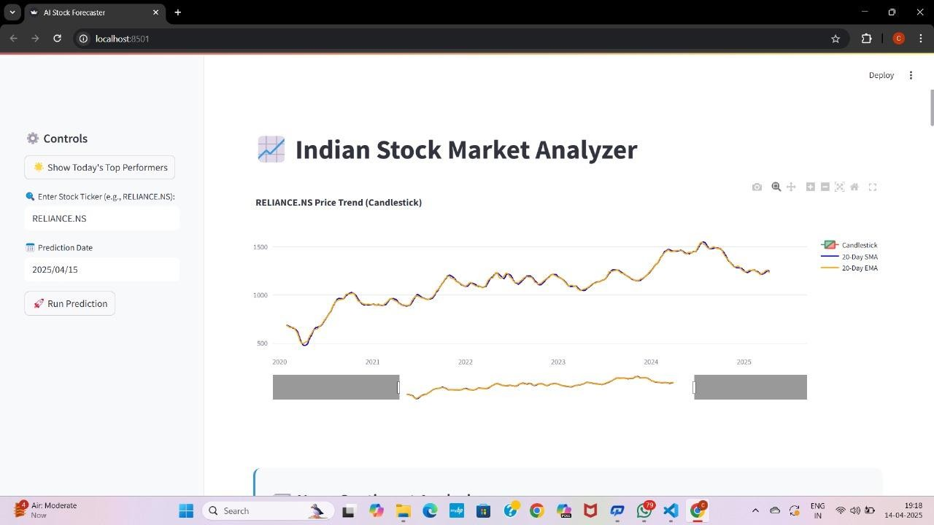

Fig.8 home page

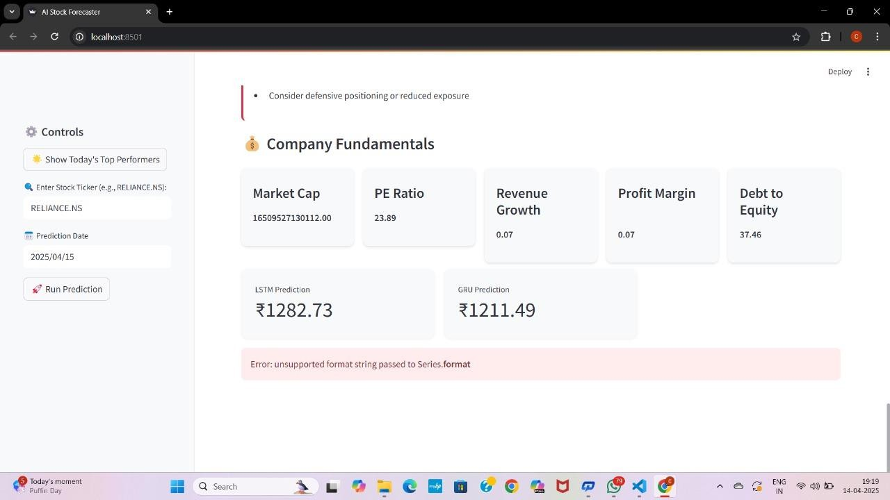

Fig.9 Today’s Top Performers

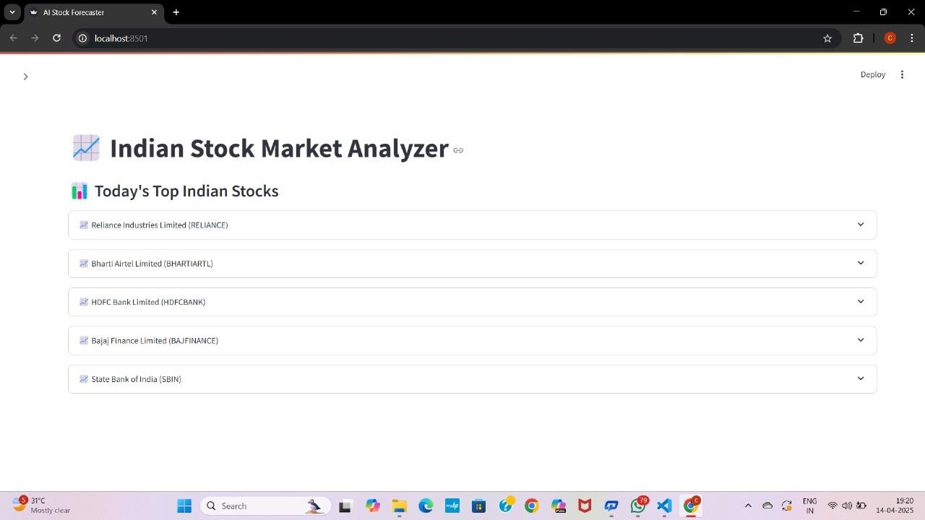
Fig.10 Today’s Top Indian Stocks - 1
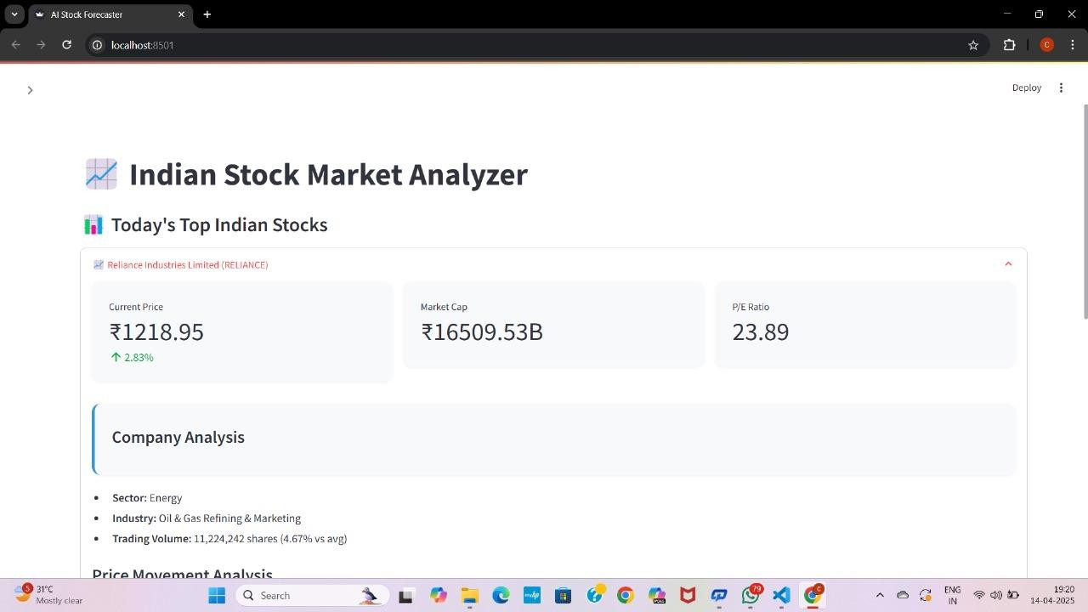
Fig.11 Today’s Top Indian Stocks – 2

CHAPTER 8

Conclusion & Future Enhancements 59-61
  - Conclusion
  - Future Enhancements

CONCLUSION & FUTURE ENHANCEMENTS

Conclusion

The Stock Market Analyzer project has effectively demonstrated the integration of artificial intelligence, financial data analysis, and user-centric design in building a tool that aids users in understanding and forecasting stock market trends. By combining historical stock data, technical indicators, sentiment analysis from financial news, and deep learning models like LSTM and GRU, the system is capable of providing valuable insights into stock price movements and market behavior.
The application successfully simplifies the complexities of stock analysis by offering features such as candlestick charts, SMA/EMA trend lines, RSI and MACD indicators, and AI-driven price predictions. It also provides sentiment scores based on real-time news headlines, giving users a broader perspective that blends both technical and fundamental aspects of stock analysis. The use of Streamlit ensures that the interface remains interactive, intuitive, and accessible even to users with minimal technical background.
From the testing and evaluation phase, it is evident that the system performs reliably, handling different types of stocks and scenarios with satisfactory results. The inclusion of INR conversion for USD-based stocks also adds flexibility for Indian users. Additionally, the modular structure of the system makes it easy to scale or update individual components without disrupting the entire application.
In conclusion, this project not only meets its core objectives but also demonstrates how modern technologies can empower individual investors and learners to make better financial decisions. It bridges the gap between raw data and actionable insights, providing a smart assistant for anyone curious about the stock market.

Future Enhancements
While the current version of the Stock Market Analyzer provides a strong foundation for stock prediction and analysis, there is ample scope for future improvements to enhance its functionality, accuracy, and user experience. Some of the potential enhancements include:

Integration of More Data Sources
Adding data from multiple sources like Google Finance, Bloomberg, or live trading APIs could improve data reliability and provide real-time updates for better analysis.

Enhanced Sentiment Analysis with NLP
Replacing TextBlob with advanced NLP models like BERT or RoBERTa could significantly improve the accuracy of sentiment classification, especially in understanding financial jargon and sarcasm.

Portfolio Management Module
Introducing a feature that allows users to build and manage a virtual stock portfolio could help them track performance over time and simulate investments.

User Authentication and Data Storage
Implementing login functionality with secure user accounts and cloud-based data storage would allow users to save their preferences, prediction history, and watchlists.

Mobile App Version
Developing a mobile application for Android/iOS would increase accessibility and allow users to get updates and predictions on the go.

Real-time Alerts and Notifications
Users could receive real-time alerts based on stock price changes, breaking news, or significant sentiment shifts, helping them make timely decisions.

REFERENCES
  - S. Fischer and R. Krauss, “Deep learning with long short-term memory networks for financial market predictions,” European Journal of Operational Research, vol. 270, no. 2, pp. 654–669, 2018.
  - N. Patel and R. Shah, “Stock market prediction using LSTM neural network,”
International Journal of Computer Applications, vol. 178, no. 7, pp. 15–22, 2019.
  - J. Bollen, H. Mao, and X. Zeng, “Twitter mood predicts the stock market,” Journal of Computational Science, vol. 2, no. 1, pp. 1–8, Mar. 2011.
  - F. A. Gers, J. Schmidhuber, and F. Cummins, “Learning to forget: Continual prediction with LSTM,” Neural Computation, vol. 12, no. 10, pp. 2451–2471, 2000.
  - K. Choudhury and A. Varma, “Stock market analysis using sentiment analysis and LSTM- based deep learning models,” Proceedings of the 5th International Conference on Intelligent Computing and Control Systems (ICICCS), pp. 1270–1276, 2021.
  - S. Hochreiter and J. Schmidhuber, “Long Short-Term Memory,” Neural Computation, vol. 9, no. 8, pp. 1735–1780, 1997.
  - A. Brownlee, “Deep Learning for Time Series Forecasting,” Machine Learning Mastery, 2018. [Online]. Available: https://machinelearningmastery.com/deep-learning-for- time-series-forecasting/
  - Yahoo Finance, “Market Data API,” [Online]. Available: https://finance.yahoo.com/
  - J. Pennington, R. Socher, and C. Manning, “GloVe: Global Vectors for Word Representation,” in Proceedings of the 2014 Conference on Empirical Methods in Natural Language Processing (EMNLP), 2014.

APPENDIX - 1

PUBLICATION DETAILS

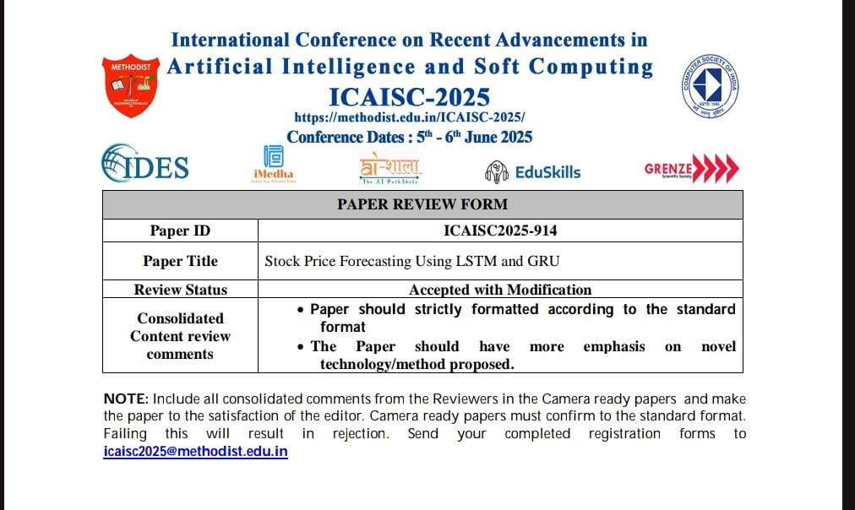

CO – PO & PSO MAPPING TABLE

Course Outcomes: On successful completion of this Project, the students will be able to
CO 1 | Demonstrate a sound technical knowledge of their selected project topic
CO 2 | Understand problem identification, formulation and solution
CO 3 | Design engineering solutions to complex problems utilizing a systems approach
CO 4 | Communicate with engineers and the community at large in written an oral form
CO 5 | Demonstrate the knowledge, skills and attitudes of a professional engineer

Project  Title | STOCK PRICE FORECASTING USING LSTM AND GRU
Course Outco mes (CO) | Programme Outcomes (PO) and Programme Specific Outcomes (PSO)
Course Outco mes (CO) | P O  1 | P O  2 | P O  3 | P O  4 | P O  5 | P O  6 | P O  7 | P O  8 | P O  9 | P O  10 | P O  11 | P O  12 | PS O 1 | PS O 2 | PS O 3
CO 1 | 3 |  |  |  |  |  |  |  |  |  |  |  | 3
CO 2 |  | 3 |  | 2 |  |  |  |  |  |  |  |  |  | 3
CO 3 |  |  | 3 |  |  | 1 |  |  |  |  |  |  |  | 2
CO 4 |  |  |  |  |  |  |  |  |  | 3
CO 5 | 3 |  |  |  |  |  |  |  |  |  |  |  |  | 2
Mapping of PO and CO
Influence of the course outcome (1 – Low, 2 – Medium, 3 – High)

RUBRICS FOR EVALUATION

Parameter/Marks(  %) | Excellent (76%-100%) | Good (51%-75%) | Satisfactory (26%-50%) | Needs  Improvement (0-25%)
Relevance & Innovation in Topic Selection (10M) | Topic is innovative, relevant, and well-justified with practical applications. | Topic is relevant but lacks strong novelty. | Topic is somewhat relevant but needs better justification. | Topic is not suitable or lacks clarity.
Analytical Thinking & Problem Interpretation (10M) | Demonstrates deep analytical thinking and strong logical interpretation of the problem. | Good analysis with minor refinements needed. | Basic analysis but lacks depth and synthesis. | Poor analysis with no clear synthesis of ideas.
Effective Problem- Solving & Implementation (10M) | Efficient problem- solving approach with optimized implementatio n. | Good problem- solving but with some inefficiencies. | Basic implementatio n, lacks optimization. | Poor problem- solving, incorrect or inefficient implementatio n.
Application of Engineering Techniques & Tools (10M) | Effective and appropriate use of modern tools, software, and technical methodologies. | Uses modern tools but needs better optimization. | Limited use of tools, lacks integration. | No or incorrect use of techniques and tools.
Societal Impact & Responsibility in Engineering (5M) | Clearly explains the societal benefits and responsible application of engineering solutions. | Considers impact but lacks depth. | Basic awareness of impact but not well integrated. | No awareness of how the project affects society.
 | Strong integration of sustainability | Some environmental considerations | Basic awareness, but not effectively | No concern for environmental

Parameter/Marks(  %) | Excellent (76%-100%) | Good (51%-75%) | Satisfactory (26%-50%) | Needs Improvement  (0-25%)
Environmental Sustainability & Green Engineering (5M) | principles with minimal environmental impact. | but minor gaps. | applied. | impact.
Ethical Considerations & Professional Responsibility (5M) | Strong ethical awareness in project work, decision- making, and implementatio n. | Ethical aspects considered but with minor gaps. | Some ethical considerations but not fully developed. | No ethical considerations in the project.
Self-Learning & Research Adaptability (5M) | Demonstrates strong ability for self- learning, exploring new domains, and independent research. | Shows interest in learning but relies partially on guidance. | Limited self- learning, depends mostly on given knowledge. | No effort towards learning beyond the syllabus.
Presentation Skills & Technical Communication (15M) | Excellent articulation, confidence, and clarity in explaining work. | Good communicatio n, with minor areas for improvement. | Lacks confidence, some difficulty in conveying ideas. | Poor presentation, unable to explain the work.
Report Writing, Documentation & Formatting (15M) | Well-structured report with proper format, citations, clarity, and  professional | Report is well- written but has minor formatting issues. | Report lacks depth, with missing or unclear sections. | Poorly written report, lacks structure and clarity.

Parameter/Marks(  %) | Excellent (76%-100%) | Good (51%-75%) | Satisfactory (26%-50%) | Needs Improvement  (0-25%)
 | presentation.
Time, Budget & Resource Management (5M) | Well-planned execution, optimizing time and cost while managing resources effectively. | Good planning but minor inefficiencies in cost or time. | Basic planning but lacks detailed breakdowns. | Poor or no time and cost analysis.
Lifelong Learning & Future Scope of Work (5M) | Demonstrates commitment to continuous learning and identifies future research opportunities. | Shows some effort in exploring future possibilities but needs improvement. | Limited awareness of further learning or enhancements. | No effort toward learning or future research considerations.

BIO – DATA OF TEAM MEMBERS

Personal Information
Name:Byreddy Gowthami
Father’s Name: Byreddy Muralidhar reddy
Date of Birth: 16/07/2003 Gender: Female
Nationality: Indian Marital Status: Single
Languages Known: English, Hindi,Telugu.
Contact: +91-9989181406
Email: gowthamibyreddy0416@gmail.com
Address: Jammalamadugu,Kadapa Dist.,India

Educational Qualifications
Qualification | Institution | Board/University | Year | Percentage/CGPA
B.Tech (Computer Science) | KSRM College  Of Engineering. | JNTUA University | 2025 | 8.1 CGPA
Class XII | Sri Chaitanya jr. College. | State Board | 2021 | 93.7%
Class X | Viswa Jyothi English Medium School. | State Board | 2019 | 95%
Technical Skills
- Programming Languages: C, Python
- Web Technologies: HTML, CSS, JavaScript
- Tools: Git, VS Code

Projects
Title: Detection of Heart Disease using machine learning.
Description: "Utilizing machine learning algorithms to analyze medical data and predict the likelihood of heart disease, enabling early detection and prevention."

Achievements / Certifications
- Certified in “Java Programming” by NPTEL – 2022

Declaration
I hereby declare that the above information is true to the best of my knowledge.

(Student Signature)

Personal Information
Name: Kamisetty Lakshmi Prasanna
Father’s Name: Kamisetty Prakash
Date of Birth: 11/04/2004
Gender: Female
Nationality: Indian Marital Status: Single
Languages Known: English,Telugu
Contact: +91-9885066593
Email: lakshmiprasanna6010@gmail.com
Address: 2/87-3,Ananthampalli,Pullampet Mandal,Kadapa.

Educational Qualifications
Qualification | Institution | Board/University | Year | Percentage/CGPA
B.Tech (Computer Science) | KSRM College  Of Engineering. | JNTUA University | 2025 | 7.8 CGPA
Class XII | SriChaitanya jr.College. | State Board | 2021 | 89%
Class X | Z.P.H.  School Ananatham  palli | State Board | 2019 | 92%
Technical Skills
- Programming Languages: C, Python
- Web Technologies: HTML, CSS, JavaScript
- Tools: Git, VS Code

Projects
Title: Movie Recommendation System Using Machine Learning
Description: Developed Recommendation System Using Machine Learning

Achievements / Certifications
- Certified in Artififial Intelligence – IGNOU
- Program essentials in python- CISCO

Declaration
I hereby declare that the above information is true to the best of my knowledge.

(Student Signature)

Personal Information
Name:G.Gresudeevena
Father’s Name: G.sriramulu
Date of Birth: 30/01/2004
Gender:female
Nationality: Indian Marital Status: Single
Languages Known: English, Hindi Contact: 9390656080
Email:ggresudeevena@gmail.com
Address:#8/160,chitluru,harijinawada,ramapuram(m),annamayya(dist)

Educational Qualifications
Qualification | Institution | Board/University | Year | Percentage/CGPA
B.Tech (Computer Science) | KSRM College  Of Engineering. | JNTUA University | 2025 | 8.0CGPA
Class XII | APSWREIS SCHOOL | State board | 2021 | 80%
Class X | APSWREIS SCHOOL | State board | 2019 | 93%
Technical Skills
- Programming Languages: C, C++, Python, Java
- Web Technologies: HTML, CSS, JavaScript
- Tools: Git, VS Code, MATLAB

Projects
Title: Smart Home Automation System
Description: Developed a home automation system using Arduino and sensors to control appliances via mobile application.

Achievements / Certifications
- Certified in Python Programming – 2023

Declaration
I hereby declare that the above information is true to the best of my knowledge.

(Student Signature)

Personal Information
Name: Chinthakunta indrakumar
Father’s Name:C.Surendra babu
Date of Birth: 20/08/2003
Gender: Male
Nationality: Indian Marital Status: Single
Languages Known: English, Hindi,Telugu
Contact: +91-9346381524
Email: indrakumarchinthakunta@gmail.com
Address: 37/1133-1-1,nehru nagar,Kadapa.

Educational Qualifications
Qualification | Institution | Board/University | Year | Percentage/CGPA
B.Tech (Computer Science) | KSRM College  Of Engineering. | JNTUAUniversity | 2025 | 7.0 CGPA
Class XII | Sri Chaitanya jr college | State board | 2021 | 70%
Class X | Nagarjuna E.M high school | State board | 2019 | 88%
Technical Skills
- Programming Languages: C, Python.
- Web Technologies: HTML, CSS, JavaScript
- Tools: Git, VS Code.

Projects
Title: Cardiovascular disease prediction using artificial neural networks
Description: This project develops an artificial neural network-based model to accurately predict cardiovascular disease risk using patient data for early detection

Achievements / Certifications
- Certified in Python Programming – 2025
- Data analytics and visualization certificate – 2025

Declaration
I hereby declare that the above information is true to the best of my knowledge.

(Student Signature)

